Self-Assessment Worksheet

Step 1 – Rating ACHIEVEMENT AREAS
Assess your system by rating your current level of achievement for each management area. Consider how effectively your current management efforts support each of the areas. Note that each management area has several dimensions (represented by the bullet points listed for each). Your rating should reflect the dimension with the lowest level of achievement. For example, if you believe that your achievement in one dimension of a management area was low, but your achievement in another dimension of that area was high, your overall rating for the area would be low. An example of the rating exercise can be found on the following page.

Scale from low achievement to high achievement:
- Select Low if your system has no workable practices in place for addressing this area – very low capacity and performance.
- Select Medium if your system has some workable practices in place with moderate achievement, but could improve – some capacity in place.
- Select High if your system has effective, standardized, and accepted practices in place. It either usually or consistently achieves goals – capacity is high and in need of very little or no further development.

Step 2 - Ranking PRIORITY AREAS

Rank the importance of each management area to your system. Base this ranking on your goals and the specific needs of your community. Your ranking may be influenced by current or expected challenges (e.g., if your community is experiencing elevated population growth rates, Water Resource Adequacy may be ranked as a high priority area to address). Again, note that each management area has multiple dimensions (represented by the bullet points listed). Your ranking should represent the highest priority of all of the points listed. Your ranking should also be independent of the achievement level. For example, an area can remain, and therefore be ranked, as a high priority even if, or after, the utility has high capacity and performance). An example of the rating exercise can be found on the following page.

Scale from low priority to high priority, keeping in mind the following:
- Current or expected challenges
- Customer or stakeholder impact (reliability, quality, timeliness)
- Consequences of not improving (non-compliance, increased cost, lost credibility, impacts to health and safety)
- Urgency (near or long term needs)
- Community priorities

Table A – Example
Key Management Area | Management Area Description | Step 1: Rate Achievement (Low – High) | Step 2: Rank Priority (Low – High)
1. Water Resource Adequacy (e.g., water quantity) | - My system is able to meet the water or sanitation needs of its customers now and for the reasonable future.  - My system or community has performed a long-term water supply and demand analysis. (Applies to drinking water systems only.)  - My system understands its relationship to local water availability. (Drinking water utilities should focus on utilization rates relative to any local water stress conditions, wastewater utilities should focus on return flows.) | Low | High
2. Product Quality  (e.g., clean & safe water) | - My system is in compliance with permit requirements and other regulatory or reliability requirements.  - My system meets local community expectations for the potable water and/or treated effluent and process residuals that it produces. | Medium | High
3. Customer Satisfaction | - Customers are satisfied with the services the system provides.  - My system has procedures in place to receive and respond to customer feedback in a timely fashion. | High | Medium
4. Community Sustainability & Economic Development | - My system is aware of and participating in local and regional community and economic development planning activities.  - My system’s goals also help to support overall watershed and source water protection, and community economic goals. | High | Low
5. Employee & Leadership Development | - Training programs are in place to retain and improve institutional knowledge.  - Opportunities exist for employee skills development and career enhancement.  - Job descriptions, performance expectations, and codes of conduct are established. | Low | Medium
6. Financial Viability | - The rates that my system charges are adequate to pay our bills, put some funds away for the future, and maintain, repair, and replace our equipment and infrastructure as needed. (O&M, debt servicing, and other costs are covered).  - My system discusses rate requirements with our customers, board members, and other key stakeholders. | Medium | High
7. Operational Optimization (e.g., energy/water efficiency) | - My system has assessed its current energy usage and performed an energy audit.  - My system has maximized resource use and resource loss (e.g., water loss, treatment chemical use).  - My system understands, has documented, and monitors key operational aspects of the system (e.g., pressure, flow, quality). | Medium | Medium
8. Infrastructure Stability  (e.g., asset management practice) | - My system has inventoried its current system components, condition, and cost.  - My system has a plan in place for repair and replacement of system components. | Low | Medium
9. Operational Resiliency | - My system has conducted an all hazards vulnerability assessment (safety, natural disasters, environmental risks, etc.).  - My utility has prepared an all hazards emergency response plan. | Medium | Low
10. Stakeholder Understanding & Support | - My system actively engages with local decision makers, community, watershed (where relevant), and regulatory representatives to build support for its goals, resources, and the value of the services it provides.  - My system performs active customer and stakeholder outreach and education to understand concerns and promote the value of clean and safe water. | Low | Low

Table A – Your Turn
Key Management Area | Management Area Description | Step 1: Rate Achievement (Low – High) | Step 2: Rank Priority (Low – High)
1. Water Resource Adequacy (e.g., water quantity) | - My system is able to meet the water or sanitation needs of its customers now and for the reasonable future.  - My utility or community has performed a long-term water supply and demand analysis. (Applies to drinking water systems only.)  - My system understands its relationship to local water availability. (Drinking water utilities should focus on utilization rates relative to any local water stress conditions, wastewater utilities should focus on return flows.)
2. Product Quality  (e.g., clean & safe water) | - My system is in compliance with permit requirements and other regulatory or reliability requirements.  - My utility meets local community expectations for the potable water and/or treated effluent and process residuals that it produces.
3. Customer Satisfaction | - Customers are satisfied with the services the system provides.  - My system has procedures in place to receive and respond to customer feedback in a timely fashion.
4. Community Sustainability & Economic Development | - My utility is aware of and participating in local and regional community and economic development planning activities.  - My utility’s goals also help to support overall watershed and source water protection, and community economic goals.
5. Employee & Leadership Development | - Training programs are in place to retain and improve institutional knowledge.  - Opportunities exist for employee skills development and career enhancement.  - Job descriptions, performance expectations, and codes of conduct are established.
6. Financial Viability | - The rates that my utility charges are adequate to pay our bills, put some funds away for the future, and maintain, repair, and replace our equipment and infrastructure as needed. (O&M, debt servicing, and other costs are covered.)  - My utility discusses rate requirements with our customers, board members, and other key stakeholders.
7. Operational Optimization (e.g., energy/water efficiency) | - My utility has assessed its current energy usage and performed an energy audit.  - My utility has maximized resource use and resource loss (e.g., water loss, treatment chemical use).  - My utility understands, has documented, and monitors key operational aspects of the system (e.g., pressure, flow, quality).
8. Infrastructure Stability  (e.g., asset management) | - My utility has inventoried its current system components, condition, and cost.  - My system has a plan in place for repair and replacement of system components.
9. Operational Resiliency | - My utility has conducted an all hazards vulnerability assessment (safety, natural disasters, environmental risks, etc.).  - My utility has prepared an all hazards emergency response plan.
10. Stakeholder Understanding & Support | - My system actively engages with local decision makers, community, watershed (where relevant), and regulatory representatives to build support for its goals, resources, and the value of the services it provides.  - My utility performs active customer and stakeholder outreach and education to understand concerns and promote the value of clean and safe water.

Step 3 - Plot Results
To compare your results for each management area, you will plot each pair (rating, ranking) in Table B of Appendix I. For each management area, identify your high/medium/low rating in the green Step 1 box, and find the corresponding row in the table. Then, for the same management area, identify your high/medium/low ranking in the blue Step 2 box, and find the corresponding column in the table. The box where the row and column intersect is where you should place that management area (note abbreviations below for use in the plotting exercise). The example below shows how you should complete the Step 3 plotting exercise. The ranking and rating for each management area should be paired and placed into the corresponding box in the grid, based on the low/medium/high determinations given in Steps 1 and 2.
WA Water Resource Adequacy  PQ Product Quality  CS Customer Satisfaction  CE Community Sustainability & Economic Development  ED Employee & Leadership Development | FV Financial Viability  OO Operational Optimization  IS Infrastructure Stability  OR Operational Resiliency  SS Stakeholder Understanding & Support

Table B – Example
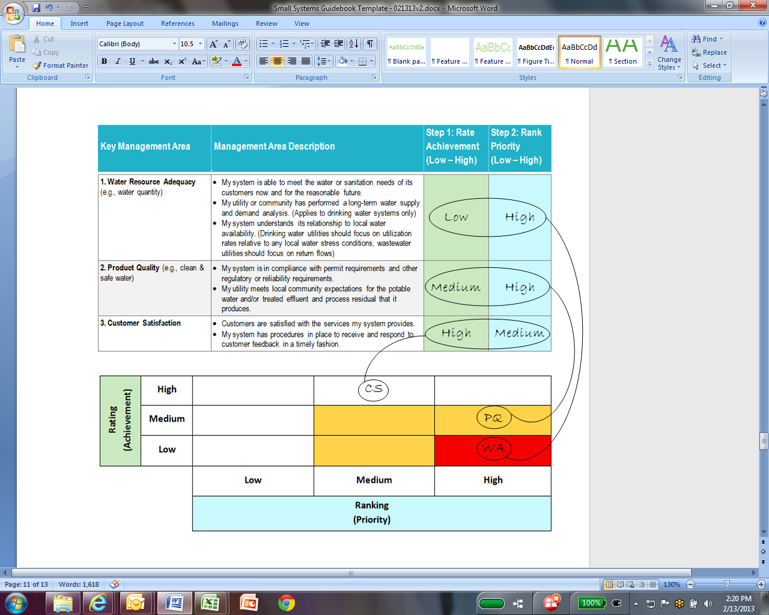

Table B – Your Turn
WA Water Resource Adequacy  PQ Product Quality  CS Customer Satisfaction  CE Community Sustainability & Economic Development  ED Employee & Leadership Development | FV Financial Viability  OO Operational Optimization  IS Infrastructure Stability  OR Operational Resiliency  SS Stakeholder Understanding & Support
Rating  (Achievement) | High
Rating  (Achievement) | Medium
Rating  (Achievement) | Low
 |  | Low | Medium | High
Ranking
(Priority)

Step 4 - Analyze Results
QUESTIONS TO CONSIDER:
Where is my utility strong?
Where is there the most room for improvement?
What should my areas of focus be?
Why are these areas priorities?
The results of the Step 3 plotting exercise identify management areas that will benefit from improvement. Generally speaking, management areas that fall into the red box are both very important and need improvement. They should be seen as a top priority for improvement. Management areas that land in the yellow boxes are next on the list for improvement, and those in the white boxes may be considered for long-term improvement efforts, but likely do not need immediate action. The eventual goal for all utilities should be high achievement in all management areas, but at a pace consistent with the system’s priorities and resources.

