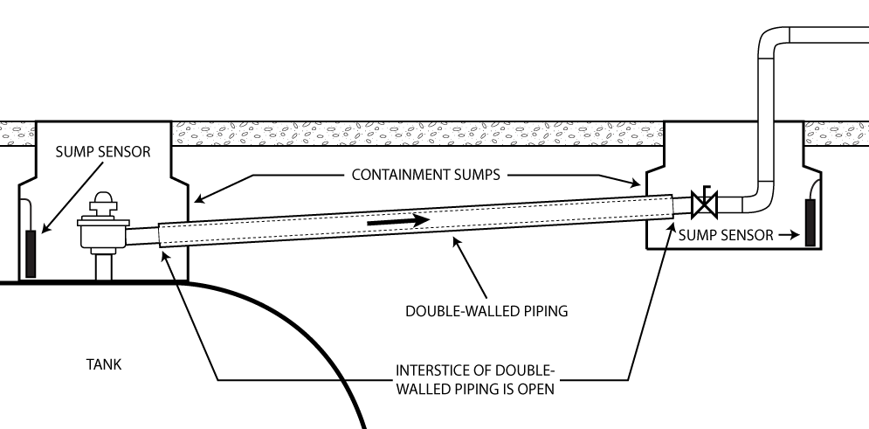
SUBMERSIBLE TURBINE PUMP (STP) SUMP
TRANSITION SUMP

In-Depth Discussion:

Automated Interstitial Monitoring Systems for Underground Pressurized Piping on Emergency Power Generator UST Systems

Contents

Purpose 1
Background 2
Section 1: Regulatory Allowance for AIM Systems and Overview of Meeting the Dual Release Detection Requirements 4
Section 2: Description of AIM Systems 6
Section 3: Recognizing AIM System Capability to Meet Regulatory Requirements 13
Section 4: Examples of Category 1 and 2 Systems 17
Section 5: Example of a Basic Category 3 System 22
Section 6. Alternative System Configurations Used for Category 3 AIM Systems 32
Section 7. O&M Testing and Inspections Requirements At A Glance 35
Section 8. Basic Test Requirements (by System Component) 38
Section 9: Required Documentation from UST System Owners and Operators 41
Section 10: AIM Systems Inspection and Testing Checklists 45
Appendix 51

Purpose
This document includes background and technical information on the U.S. Environmental Protection Agency’s (EPA’s) recognition of using automated interstitial monitoring (AIM) systems to meet federal release detection requirements for underground pressurized piping systems on emergency power generator (EPG) UST systems. Owners and operators must obtain approval from their UST implementing agency to use an AIM system. EPA has provided a Certification of Compliance Form to assist owners and operators with their approval request. State UST implementing agencies might not allow these systems in their jurisdictions or may require different or additional information to verify design and installation criteria have been met.

The intent of this document is to familiarize state UST implementing agencies with the concept of AIM systems to consider allowing use of these systems in their jurisdictions. This document also can assist UST system installers, fuel system designers, and other qualified professionals when installing or modifying fuel storage systems to meet federal UST regulatory requirements for underground pressurized piping systems. AIM systems are optional, and state UST implementing agency requirements may be different.

This is a companion document to these EPA publications:
- Owner And Operator Introduction: Automated Interstitial Monitoring Systems for Underground Pressurized Piping on Emergency Power Generator UST systems, and
- Federal UST Requirements for Emergency Power Generator UST Systems.

Background
A wide variety of automatic line leak detectors, both electronic and mechanical, are commercially available for most regulated UST systems. They help meet the federal release detection requirement for underground pressurized piping. Manufacturers, third-party release detection equipment, and method evaluators have categorically verified the circumstances under which these devices are capable of meeting performance standards in the federal UST regulation. Manufacturers and evaluators followed EPA’s release detection methods evaluation test procedures to verify performance criteria.

The federal UST regulation relies on performance-based standards for release detection equipment performance criteria to protect human health and the environment. Owners and operators may use non-traditional release detection methods or combinations of methods to meet regulatory requirements, including to detect releases from pressurized piping.

Regarding pressurized piping release detection, EPA specifically stated in the preamble to the original 1988 federal UST regulation (Federal Register Vol. 53, No 185, September 23,1988, p. 37153):

“The Agency notes that one release detection method can be used as the sole method if it can meet both the hourly release detection requirement and the annual or monthly release detection requirement. For example, double-walled piping with interstitial monitoring that meets the performance standard continues to be an acceptable option for pressurized piping and would not require shutoffs, restrictors, or tightness tests. The system must be equipped, however, with an alarm that will indicate when a release into the interstitial space has begun.”

In the preamble language above, the concept of continuous interstitial monitoring, referenced herein, is described as an automated interstitial monitoring system. For EPG UST systems, an AIM system can meet equivalent requirements for catastrophic line leak detection (3 gallons per hour [gph] at 10 pounds per square inch [psi] line pressure within 1 hour) and monthly monitoring (0.2 gph) for pressurized piping systems.

While AIM systems may be technically feasible for use with conventional UST systems such as at gasoline service stations, EPA’s recognition for use of these systems is recommended only for EPG UST systems. In many jurisdictions, conventional UST systems must meet fire code requirements that require installation of a listed (as defined below) leak detection device on the discharge side of the pump at facilities that dispense motor fuel. Thus, interstitial monitoring-based AIM systems cannot be used; EPA does not recommend they be used as an alternative means of meeting pressurized piping release detection when fire code requirements must be met. Depending upon the jurisdiction, either Chapter 23 (Motor Fuel-Dispensing Facilities and Repair Garages) of the International Fire Code (IFC) or NFPA 30A, Code of Motor Fuel Dispensing Facilities and Repair Garages, which is published by the National Fire Protection Association, will be applicable. Both codes cover motor fuel-dispensing facilities that dispense liquid and gaseous motor fuels into fuel tanks of automotive vehicles and marine craft.

IFC Section 2306.7.7.1 Leak detection
Where remote pumps are used to supply fuel dispensers, each pump shall have installed, on the discharge side, a listed detection device that will detect a leak in the piping and provide an indication. A leak detection device is not required if the piping from the pump discharge to under the dispenser is above ground and visible.

NFPA 30A Section 5.4.4 Leak Detection.
On remote pressure pumping systems, each pump shall have installed, on the discharge side, a listed leak detection device that will provide an audible indication, a visible indication, or will restrict or shut off the flow of product if the piping and dispensing devices are not liquid-tight.

IFC defines the term listed as equipment, materials, products or services included in a list published by an organization acceptable to the fire code official and concerned with the evaluation of products or services that maintains periodic inspection of production of listed equipment, materials or periodic evaluation of services and whose listing states either that the equipment, material, product or service meets identified standards or has been tested and found suitable for a specified purpose.

NFPA defines the term listed as equipment, materials, or services included in a list published by an organization that is acceptable to the authority having jurisdiction and concerned with the evaluation of products or services, that maintains periodic inspection of production of listed equipment or materials or periodic evaluation of services, and whose listing states that either the equipment, material, or service meets appropriate designated standards or has been tested and found suitable for a specified purpose.

Section 1: Regulatory Allowance for AIM Systems and Overview of Meeting the Dual Release Detection Requirements

General Discussion about Using AIM Systems on Pressurized Piping Systems
Note: To comply with Energy Policy Act of 2005 requirements, most state UST implementing agencies established compliance dates for their secondary containment and interstitial monitoring requirements that pre-date the federal compliance date.
The federal UST regulation requires that UST system owners and operators with underground pressurized piping equip their systems with an automatic line leak detector that will alert the owner or operator to the presence of a leak. The alert either restricts or shuts off the flow of regulated substances through piping or triggers an audible or visual alarm. In addition to the automatic line leak detector, UST system owners and operators must have a second release detection method by meeting one of these two requirements, as applicable:

- Pressurized piping installed on or before April 11, 2016, must have an annual line tightness test conducted according to 40 CFR § 280.44(b) or have monthly monitoring conducted according to 40 CFR § 280.44(c).

- Pressurized piping installed or replaced after April 11, 2016, must use monthly interstitial monitoring according to 40 CFR § 280.43(g).

This document uses the terms monthly or month and annually or annual. These terms in the context of federal release detection requirements mean at least once every 30 days and not to exceed 365 days, respectively.
For all pressurized piping systems associated with EPG UST systems, regardless of the installation date of the piping system, EPA recognizes the use of an AIM system, as described in this document, as an option to meet both release detection requirements for pressurized piping systems.

AIM systems are continuous interstitial monitoring systems comprising multiple parts that rely on detection of breaches to the interstice from the primary or secondary walls in category 1 or 2 systems. Category 3 systems rely on the detection of breeches from the primary to the interstice. These qualitative release detection methods are not expressed as pass or fail, which indicates a tight or not-tight condition, respectively.

Achieving the volume aspects of the federal UST release detection requirements by category 1, 2, and 3 AIM systems is relatively straightforward. These volume aspects are the 0.2 gph leak rate for the monthly monitoring requirement and 3 gph at 10 psi line pressure equivalent for the automatic line leak detector (ALLD) performance standard. In addition, meeting the frequency requirement of once per 30-days monitoring frequency associated with the 0.2 gph leak standard is also relatively straightforward to achieve for each category of AIM system. Each category of AIM system is a continuous monitoring method. Continuous monitoring of both the inner and outer walls by pressure, vacuum, or liquid-filled piping interstitial spaces, performed by category 1 and 2 systems, respectively, and continuous monitoring for potential breaches from the primary wall for category 3 systems, exceeds the once per 30-day monitoring frequency. EPA also recognizes AIM systems designed, installed, and tested as described in this document as meeting federal UST regulatory probabilities of detection and false alarm requirements for the ALLD performance standard.

Section 2: Description of AIM Systems

This section describes key features and use of AIM systems to meet release detection requirements for pressurized piping on EPG UST systems.

General Description
AIM systems are secondary containment systems that include piping and all connected containment sumps, e.g., submersible turbine pump, transition, collection, and detection containment sumps. The piping and connected sumps have been specifically designed and constructed by the system manufacturer or installer in accordance with a code of practice Underwriters’ Laboratories (UL) or other nationally recognized association) for containment purposes and are compatible with fuels stored in the EPG UST system.

The AIM system must meet the dual release detection requirements, meaning the combined performance standards required by:

- 40 CFR § 280.41(b)(1)(i)(A) & 280.44(a) for an ALLD: 3 gph at 10 psi line pressure within 1 hour.
- 40 CFR § 280.43(g)(1) (in accordance with 280.44(c)) for monthly, that is, every 30 days, interstitial monitoring for double-walled piping.

The AIM system must be designed, constructed, and installed to detect a leak from any portion of the piping that routinely contains product. The sampling or testing method used in the AIM system must be able to detect a leak through the inner wall in any portion of the piping that routinely contains product.

Interstitial communication is a crucial part of an AIM system because the federal UST regulation requires that the sampling or testing method be able to detect a leak through the inner wall in any portion of the piping that routinely contains product. Interstitial communication relies on the integrity of the secondary wall of an AIM system to ensure product leaked from an inner wall breach is detected by the sampling or testing method. The interstice is a critical component of the sampling or testing method.

The AIM system must provide facility notification in the event of a suspected release at a minimum equivalent to the 3 gph at 10 psi within a one-hour performance standard for in-line piping release detection. The piping interstitial space is monitored continuously, and audible or visual alarms notify owners and operators of leaks. UST system owners and operators must respond by taking appropriate action according to requirements at 40 CFR Subpart E—Release Reporting, Investigation, and Confirmation. For purposes of AIM systems, EPA defines continuously monitored and monitored on a continual basis as a method controlled by an electronic or automated mechanism that performs leak detection on an uninterrupted basis and provides an alarm within one hour of the beginning of the leak. The method must communicate an alarm condition to a specific individual or individuals, such as a designated Class A, B, and C operator or petroleum or power services contractor.

List of Key Components of AIM Systems
- Double-walled piping with full interstitial communication
  - Piping that is a secondarily contained system. It is a pipe within a pipe, or pipe encased in an outer covering with an interstitial space between the outer and inner piping walls. All components must be compatible with the product stored.
- Monitoring points: pressure, vacuum, or liquid reservoirs (category 1 and 2 systems) or containment sumps (primarily category 3 systems)
  - Dedicated areas used to monitor piping for loss of product or change in condition of pressure, vacuum, or liquid level.
- Sensors
  - Pressure sensors or liquid-detecting sensors (category 1 or category 2 systems, respectively)
    - Sensors designed to respond to changes in pressure (vacuum) or changes in liquid-level within monitoring reservoir.
  - Liquid-detecting sensors (category 3 systems) using various operating principles such as float-based, optical, and hydrocarbon polymer sensitive.

- Leak detection monitoring console with alarm system (audible or visual)
  - An automatic tank gauging system or other system controller (i.e., console) that works in conjunction with the pressure, vacuum, or liquid reservoirs, or liquid-detecting sensors to determine potential product loss from the AIM system. They contain an audible or visual alarm component that is configured to relay an alarm condition to an appropriate alarm. The alarm condition must be conveyed to the attention of specific individuals such as a designated Class A, B, or C operator or petroleum or power services contractor within one hour of the suspected release.

The Three Categories of AIM Systems
Note: Category 1 and 2 systems also will use containment sumps and liquid-detecting sensors to meet the piping interstitial monitoring requirement associated with secondary containment areas. Unless all piping components within a sump are double-walled or otherwise secondarily contained, the underlying sump is the secondary containment and must be monitored for releases. This is typically accomplished using a liquid-detecting sensor.
There are three categories of AIM systems: category 1, category 2, and category 3. An audible or visual alarm notifies a breach in any of these systems.

- Category 1 is a pressure or vacuum system that monitors changes in pressure or vacuum levels within the interstice. This system continually monitors the integrity of both the inner and outer walls of double-walled piping.
- Category 2 is a liquid-filled system that monitors changes in the level of a liquid, such as brine or propylene glycol solutions, within the reservoir holding the interstitial liquid. This system also continually monitors the integrity of both the inner and outer walls of double-walled piping.
- Category 3 is a dry interstice system. This system uses float-based or other type sensors, typically located in containment sumps to monitor dry interstitial spaces, that are used for piping interstitial monitoring. Category 3 AIM systems use liquid-detecting sensors to monitor for leaks through the inner wall. A breach of product through the primary wall is conveyed through the interstice to the containment sump where it contacts the sensor.

Properly installed categories 1 and 2 AIM systems, with tight secondary containment, can detect breaches at the 3 gph at 10 psi performance standard and be set to automatically trigger an audible or visual alarm well within the required period of 1 hour. For category 3 systems to meet all aspects of this performance standard, there are limitations to the distance between sensor placement that are based on pipe type, the interstitial pipe volume, uniform sloping, and pump pressure.

Categories 1, 2, and 3 AIM systems comprise the same components, except that category 1 and 2 systems contain a pressure or vacuum monitor, or liquid monitoring reservoir, respectively, located at various places in the piping run. These two categories of AIM systems also include containment sumps or transition sumps at the end points or connection points for double-walled piping; but monitoring pressure, vacuum, or liquid levels is performed at the monitoring reservoir.

Category 3 systems do not contain a monitoring reservoir but instead contain a single containment sump or multiple sumps used as monitoring areas by liquid-detecting sensors for breaches from the inner wall. See Section 3 “Addressing the Key Concern with Category 3 Systems,” for more details about EPA’s concern with category 3 systems meeting regulatory requirements.

Design Considerations for AIM Systems
Note: Piping monitoring in category 1 and 2 systems is limited to the double-walled piping of the system. Unless all piping components that routinely contain product are monitored by vacuum, pressure, or liquid, as applicable, by the monitoring reservoir, the single-walled piping components that are typically contained in the containment sumps must also meet all monitoring requirements. For more information, see Monitoring Points on page 10.

Double-Walled Piping Construction
The piping must be double walled and meet federal secondary containment requirements. For example, UL 971-listed piping meets this requirement. Piping installed within polyvinyl chloride (PVC) pipe or within an access pipe or chase pipe does not meet these requirements unless both the inner and outer walls are evaluated and listed under UL 971. All components must be compatible with the product stored.

Chase piping that was not manufactured or intended to be used as secondary containment (for example, non-compatible corrugated chase piping and PVC pipe) does not meet this requirement.

The piping and secondary containment system must be installed according to an applicable nationally recognized code of practice, such as Petroleum Equipment Institute or American Petroleum Institute’s recommended practices and manufacturer instructions.

Piping Integrity
For each category of AIM systems, the integrity of secondary containment is critical for the system to work. The piping and a small portion of the containment sump(s) are the line leak detector. If there is no integrity, category 1 and 2 systems will almost immediately identify loss of integrity.

Piping Communication
The interstice of the double-walled piping must be unobstructed and:

      - allow pressure, vacuum, or liquid for category 1 and 2 systems to reach each monitoring point; or
      - product for category 3 systems must flow unimpeded to each monitoring point so notification of a suspected release can occur within one hour.

Pressure, vacuum, liquid, or product must be demonstrated to flow unimpeded during the testing of the piping integrity by air pressure testing the secondary containment with a pressure gauge located at the opposite end from where pressure is introduced.

Piping Slope and Length
For category 3 systems, the slope of the pipe should not include low points that allow product to pool and delay detection. For double-walled piping of inconsistent slopes, significant changes of direction, or for relatively long lengths, intermediate containment sumps along the length of the piping may be necessary to detect suspected releases within one hour. Additional evaluation and verification may be required to assure the performance standard is met in the above situations. Note that the interstice of double-walled piping should be left open within each monitored containment sump and not use jumper tubes to connect one piping interstice to another to ensure the most efficient means of interstitial communication. See the Monitoring Points section below for a note regarding the use of containment sumps that are considered part of piping secondary containment and may need to be installed to meet piping interstice integrity testing requirements. For all three categories, additional verification by the equipment manufacturer, installer, or licensed professional engineer (PE) might be required for use on AIM systems that are installed through multiple story structures where an underground segment cannot be isolated.

Monitoring Points
For category 1 and 2 systems, maintain reservoirs to monitor pressure, vacuum, or liquid levels according to the manufacturer’s written instructions.

For all categories of AIM systems, maintain containment sumps used as piping interstitial monitoring points and confirm they are tight.

Regarding where containment sumps are typically used and must be monitored as part of the federal piping interstitial monitoring requirement:

- To meet the secondary containment requirement for piping, all underground piping components must have secondary containment. All piping components must be double-walled or otherwise secondarily contained. This includes piping tees, flex connectors, and other piping components that connect the storage tank to the day tank or emergency generator. Containment sumps are considered part of the secondary containment system for single-wall piping or piping components. These sumps are typically installed at the end of piping runs. The double-walled piping interstice is open within these sumps and in the event of inner wall failure, product collects in the sump and may be monitored by using a liquid-detecting sensor. Transition sumps are typically installed on piping runs transitioning between underground and aboveground. All underground piping installed within these transition sumps are considered below ground or underground and are subject to the secondary containment requirement. These transition sumps serve as secondary containment for piping tees, flex connectors, and other piping components that are typically single walled. Therefore, these sumps must be monitored as part of the piping interstitial monitoring requirement.

- To meet piping interstice integrity testing requirements, both ends of the piping run must be accessible to perform a test. Again, a containment sump is typically used at both ends of double-walled piping runs. When installed, these containment sumps become part of secondary containment for the piping and, therefore, must be monitored as part of the piping interstitial monitoring requirement.

Liquid-Detecting Sensors
Liquid-detecting sensors must be able to detect a liquid. They must also alert the operator of a suspected release in conjunction with a leak detection monitoring console. Liquid-detecting sensors should be third-party certified to detect the targeted liquids. Some UST implementing agencies require sensors and other release detection equipment to be listed by the National Work Group on Leak Detection Evaluations (NWGLDE).

Liquid-detecting sensors must be installed at the lowest point within the containment sump, preferably in contact with the bottom of the sump, unless prohibited by the manufacturer’s instructions or UST implementing agency requirements. This allows for the earliest detection of any liquid in the sump.

Sensors must be included in all low-point sumps, including STP, transition, or collection and detection containment areas.

The sensor should be tested for the type of liquid it is targeting.

Leak Detection Monitoring Console
Leak detection monitoring consoles, in conjunction with the pressure, vacuum, or liquid reservoirs in category 1 and 2 systems, or liquid-detecting sensors in category 3 systems, must be able to alert specific individuals, such as a designated Class A, B, or C operator or petroleum or power services contractor, to any suspected release within one hour of a leak occurring. The system must be set up to properly connect to cell phones or other relay systems, as applicable, to alert specific individuals within one hour of the occurrence of a leak.

Alarm Systems
Automatic tank gauging systems and other systems controllers containing audible or visual alarm components or that can be configured to relay an alarm condition to an appropriate alarm may be used at EPG UST systems. Many EPG UST systems contain a panel of sophisticated alarms in a control room that is not usually associated with typical UST sites. Regardless of the type of alarm, the alarm condition must be conveyed to the attention of specific individuals, such as a designated Class A, B, or C operator or petroleum or power services contractor, within one hour of the suspected release incident. Conveying or notifying an alarm condition applies to staffed and unstaffed locations.

Section 3: Recognizing AIM System Capability to Meet Regulatory Requirements

The federal UST regulations establish the performance standard for ALLDs to detect a leak of 3 gph at 10 psi line pressure within one hour. This quantitative performance standard is stated for in-line piping release detection methods that, by design, continuously monitor the in-line piping fluid pressure. AIM systems continuously monitor the piping secondary space for a leak from the primary piping. AIM systems do not rely on direct indications of fluid pressure or volume changes within the primary piping to identify a potential leak. They also do not indicate quantitative results as primary piping release detection methods do.

Category 1 and 2 AIM Systems
Category 1 and 2 systems’ capability to meet the 3 gph at 10 psi standard within one hour relies on the interstitial space having integrity. EPA used the industry standard for secondary containment piping integrity testing as a means of determining whether these AIM system categories can meet the ALLD performance standard. If tightness testing of secondary piping can detect an air leak equivalent to a 3 gph at 10 psi fluid leak, then equivalency of these AIM systems to the performance standard is verified.

Petroleum Equipment Institute’s (PEI) RP 1200, Recommended Practices for the Testing and Verification of Spill, Overfill, Leak Detection and Secondary Containment Equipment at UST Facilities, provides a procedure for piping secondary containment integrity testing. This test procedure requires bringing the piping interstitial space to a test pressure of 5 psi and observing for one hour. The criteria for this test to meet and yield a passing result is no loss in pressure during the duration of the one-hour test period.

EPA used an orifice, or hole, the size equivalent to a 3 gph at 10 psi fluid leak from a pressurized line to determine whether PEI RP 1200 can detect the air loss from this equivalent orifice size during piping secondary containment integrity testing.

Theoretically, category 1 and 2 systems don’t have an interstitial volume limit. To determine whether PEI RP 1200 would detect an equivalent orifice size leak of 3 gph at 10 psi line pressure in these systems, EPA used a 750-gallon capacity interstitial air space for this comparison. EPA reasoned that this capacity would address most EPG UST systems. Approximately 254 gallons of additional air are needed to pressurize a 750 gal air space to 5 psi. Between test pressures of 5 and 1 psi, the flow rate of air through the equivalent 3 gph at 10 psi orifice is between approximately 851 gph (5 psi) and 425 gph (1 psi). As gauge pressure approaches 0 psi, the air leak rate through the orifice approaches 0 gph. With only 254 gallons of additional air released during testing, an air leak rate exceeding 425 gph in the pipe interstice would result in a discernable drop in gauge pressure well within the standard one-hour period of the piping secondary containment integrity test period.

Analyzing the capability of PEI RP 1200’s piping interstitial integrity testing to detect a breach equivalent to an orifice size leak of 3 gph at 10 psi shows that category 1 and 2 AIM systems can detect a leak equivalent to the 3 gph at 10 psi line pressure loss.

The above analysis represents the upper limit of 750 gallons piping interstitial volume to be allowed for use on category 1 and 2 systems. Category 1 and 2 systems, by design, continuously monitor pressures in the piping interstitial space. However, Tables 1 and 2 identify several listings of equipment that have been third-party evaluated. These equipment evaluations were not specifically evaluated for use on or as AIM systems detailed in this document. The equipment is potentially adaptable for use in category 1 and category 2 AIM systems that could meet the design criteria for use on EPG UST systems.

Category 1 and 2 systems are ideal systems to use. A potential product loss is indicated by the system almost immediately indicating a loss of pressure, vacuum, or liquid, as applicable, in the interstice. The system alarm is triggered, and the facility can quickly respond to this suspected release.

For more information on the analysis to determine the capability of piping interstitial integrity testing to detect a breach equivalent to a 3 gph at 10 psi leak rate within one hour, see Appendix: Comparison of Equivalent 3 gph Leaks - Formulas and Rationale.

Category 3 AIM Systems
Category 3 system’s capability to meet the 3 gph at 10 psi standard within one hour also relies on the interstitial space having integrity. However, the operating principle of these systems presents a major concern. This category of systems is designed for the secondary containment to operate at atmospheric pressure. Based on using the pump operating pressure to determine the equivalent volume of fuel compared to 3 gph at 10 psi, the volume released in one hour is assumed to be that which will fill the pipe interstice and the containment sump to the activation point of the liquid detecting sensor. This makes the length of piping—that is, the total interstitial volume of the double-walled piping—and distance to sensors critical to category 3 systems in meeting the one-hour response period. For category 3 systems, the length of piping and placement of sumps containing the dry interstitial sensor, as monitoring point, is dictated by the submersible pump operating pressure used by the EPG UST system and the calculated fuel leak rate through an equivalent 3 gph at 10 psi orifice.

The key concern with category 3 AIM systems to meet the ALLD performance standard is ensuring that a leak equivalent of 3 gph at 10 psi line pressure is detected by this passive piping interstitial monitoring system within 1 hour of occurrence of that size leak. The worst-case scenario is detecting a breach in the primary wall occurring at the furthest point from the sensor. This product leak must be communicated or conveyed by the secondary wall and detected by the sensor.

Addressing the Key Concern with Category 3 Systems
When using a category 3 system, it is considerably more difficult to achieve and harder to verify within the period of 1-hour that a leak through the inner wall in any portion of the piping that routinely contains product has occurred. Category 3 systems monitor dry interstitial spaces using a liquid-point or other type of passive sensor to ensure that a leak through the inner wall is detected. This operating principle vulnerability of category 3 systems increases the likelihood to miss potential product releases within the required one-hour period. Category 3 systems may appear to be functioning appropriately, despite product actively escaping through a breach in the secondary wall. The release detection system may not detect these product leaks in the time frame required by the regulations. The release detection system may never indicate a suspected release because product may never reach the sensor. This inherent limitation with category 3 systems must be addressed to ensure they can detect potential product releases within the one-hour criteria for the ALLD performance standard to indicate whether there is a suspected release of product. Category 3 systems are characteristically vulnerable to missing released product, and effective use of these systems is challenged by the low product throughput and infrequently used nature of EPG UST systems. These systems are typically only cycled monthly or weekly for system testing.

As a result, distances between containment sumps containing sensors used for dry interstitial monitoring of piping in category 3 systems are notably shorter than distances allowed between monitoring reservoirs for category 1 and 2 systems. For category 1 and 2 systems, monitoring reservoirs are typically placed as far apart as at the end points of piping runs when monitoring by pressure or vacuum, or liquid-filled interstices using category 1 and 2 systems, respectively. In comparison, category 3 systems typically rely upon sloped piping. Piping slope is not a requirement for these systems but because of gravity, should speed the transport of product leaks from the primary wall toward the sensor. See Section 5: Example of Basic Category 3 System for more information.

Section 4: Examples of Category 1 and 2 Systems

NWGLDE Listed Potentially Adaptable Systems
Tables 1 and 2 provide information presented on the NWGLDE website. There are several listings of equipment that have been third-party evaluated. These equipment evaluations are not specific for use on or as AIM systems detailed in this document. The equipment is potentially adaptable for use in category 1 and category 2 AIM systems designed for EPG UST systems.

Owners and operators who want to use these systems need to evaluate their EPG UST sites based on the capabilities of the individual system and how the listed equipment operates to determine whether that system is acceptable for use. Some of the vacuum methods listed, for example, rely on the turbine pump to continuously maintain a partial vacuum within the interstitial space of the double-walled piping. Given the infrequency of pump runtime for EPG UST systems, for example, an alternative vacuum generating source may be necessary to allow proper equipment function. The methods may require further evaluation regarding applicability to meet design criteria and potential system limitations described in this document.

The equipment listed in Table 1 applies to category 1 systems; equipment listed in Table 2 applies to category 2 systems. Reference NWGLDE’s website for current information.

Table 1 - NWGLDE Listings for Continuous Interstitial Line Monitoring Method (Pressure/Vacuum)

Table 1
Vendor | Equipment Name | (Release Detection Capability) Operating Principle/Max Pipeline Length | Link to NWGLDE Listing
Core Engineered Solutions | Safesite Vacuum Interstitial Monitoring System | 0.1 gph / 95.0% probability of detection (PD) / <5.0% probability of false alarm (PFA). System uses a vacuum generated by a vacuum pump or submersible pump to continuously maintain a partial vacuum of 7.5 pounds per square inch in gauge (psig), equivalent to 207.6-inch water column for 60 minutes and maintain vacuum for 30 seconds prior to testing. System is designed to activate a visual and acoustic alarm, and optional submersible pump shutdown before stored product can escape to the environment. System was evaluated for detecting breaches within the interstitial space of ⅛ inch or greater of a double-walled tank or double-walled piping. The volume of monitored interstitial space must not exceed 270 gallons or 5,690 feet of piping. | http://nwglde.org/evals/core_engineered_a.html
SGB (Sicherungsgeratebau GmbH) | Overpressure Leak Detection System Model DLR-G | Not determined / System uses pressurized nitrogen gas to continuously maintain an overpressure within the interstitial space of double-walled piping. System is designed to activate a visual and acoustic alarm before stored product can escape to the environment. System is capable of detecting breaches in both the inner and outer walls of double-walled piping (Method not limited by pipe length.) | http://nwglde.org/evals/sgb_a.html
Veeder-Root | Secondary Containment Leak Detection (SCLD) TLS-450Plus and TLS-350/ProMax/EMC Console with Vacuum Sensors 857280-100, 200, 30x, or Assembly 332175-001 | Not Determined / System uses vacuum generated by the turbine pump to continuously maintain a partial vacuum within the interstitial space of double-walled tanks and double-walled piping. System is designed to activate a visual and acoustic alarm, and optional turbine pump shutdown before stored product can escape to the environment. System is capable of detecting breaches in both the inner and outer walls of double-walled tanks and double-walled piping. / (Method not limited by pipe length) | http://nwglde.org/evals/veeder_root_zu.html

Table 2 - NWGLDE Listings for Continuous Interstitial Monitoring Method (Liquid Filled)

Table 2
Vendor | Equipment Name | (Release Detection Capability)  Operating Principle/Max Pipeline Length | NWGLDE Web Listing
Ameron International | Dualoy 3000/LCX and MCX Pipe Monitoring System Liquid Filled Interstitial Space | An applicable liquid is used to fill the Ameron Dualoy 3000/LCX and MCX fiberglass double-wall pipe interstice.  A reservoir at the high point of the system contains a dual-point level sensor that will alarm if the liquid level is too high or too low. / 344 feet | http://nwglde.org/evals/ameron_a.html
Ameron International | Dualoy 3000/LCX and MCX Pipe Monitoring System Liquid Filled Pressurized Interstitial Space | An applicable liquid is used to fill the Ameron Dualoy 3000/LCX and MCX fiberglass double-wall pipe interstice, which is pressurized using an air compressor or gas bottle.  A reservoir contains a dual-point level sensor that will alarm if the liquid level is too high or too low. / 344 feet | http://nwglde.org/evals/ameron_b.html
Western Fiberglass, Inc. | Co-Flow Hydraulic Interstitial Monitoring System | Propylene glycol is used to fill the Western Fiberglass, Inc., double-walled/coaxial flexible pipeline interstice.  Two reservoirs are used to contain the liquid, one at each end of the system. / 200 feet | http://nwglde.org/evals/western_fiberglass_a.html
Western Fiberglass, Inc. | Co-Flow Hydraulic Interstitial Monitoring System Propylene Glycol Filled Pressurized Interstitial Space | Propylene glycol is used to fill the Western Fiberglass, Inc., double-walled/coaxial flexible pipe interstice.  A pressurized cylinder is used to maintain pressure in the reservoir. / 200 feet | http://nwglde.org/evals/western_fiberglass_b.html
Western Fiberglass, Inc. | Liquid-Filled Reservoir for Double-Wall Sumps with Liquid Sensor Models WF-3 and WF-750 | Propylene glycol is used to fill the Western Fiberglass double-walled sump or under dispenser containment sump interstice. / Not applicable. | http://nwglde.org/evals/western_fiberglass_c.html

Category 1 Systems: Continuous Monitoring using Pressure or Vacuum-Based Methods

Example 1.1 (Pressure)

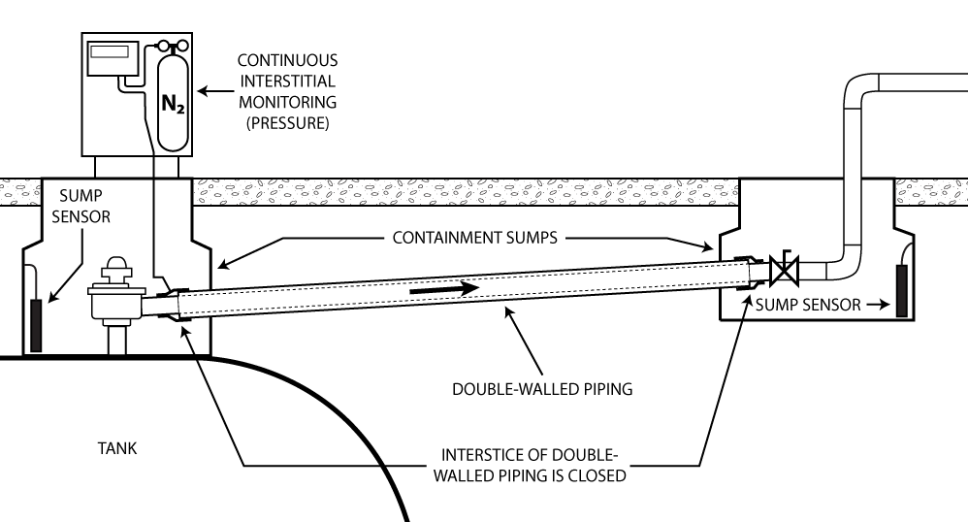
SYSTEM
END
POINTS

Example 1.2 (Vacuum)

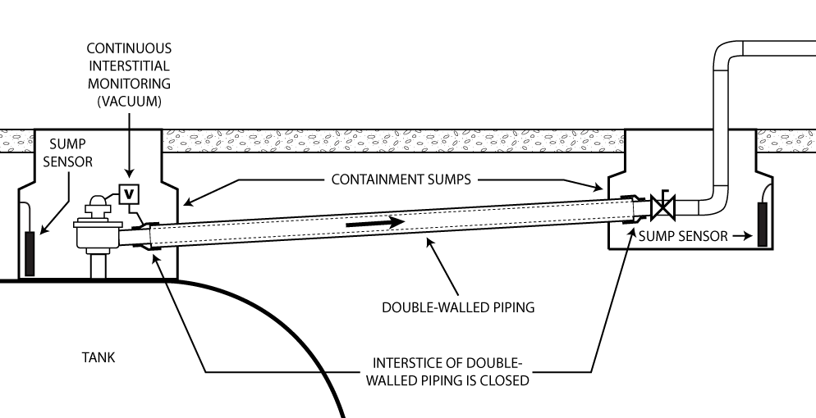
SYSTEM
END
POINTS

Category 2 Systems: Continuous Monitoring using Liquid-Filled Piping Interstice Methods

Example 2.1 (Liquid-Filled)
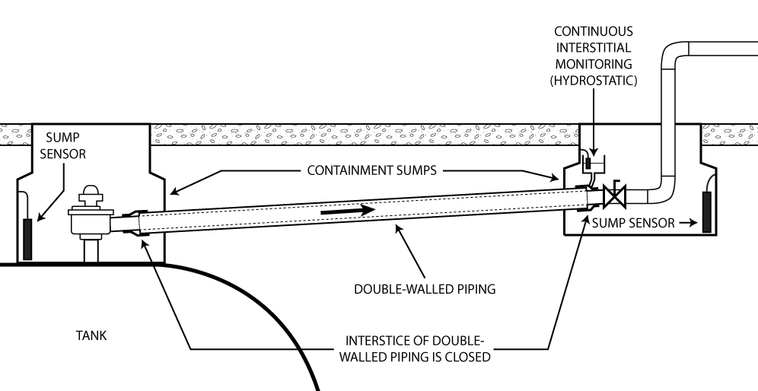
SYSTEM END POINTS

Section 5: Example of a Basic Category 3 System

Category 3 Systems: Liquid-Detecting Sensor in Containment Sump Monitoring Interstice of Double-Walled Pipe

Example 3.1 (Liquid Detecting Sensors – Sump Monitoring to Sensor Activation Point)
When using category 3 AIM systems, do not exceed distances for maximum piping length (in feet) Between Sensors noted on either Table 3 or 4, as applicable. Under conditions identified below, the distances noted in Tables 3 and 4 represent the maximum extent of sensor placements that ensure a potential product release from the primary wall can be identified to meet the catastrophic, 3 gph at 10 psi within one-hour regulatory performance standard associated with ALLDs. Depending on factors such as the size of the sump, sensor threshold placement, and sensor type, maximum piping lengths shown on the tables may not be achieved. Suggested system improvements are provided below to assist in enhancing systems to achieve noted maximum piping lengths.
A basic category 3 AIM system design depicted below highlights two key system components of this standard design: double-walled piping, that is, total interstitial volume of the double-walled piping, and the sumps being monitored by dry interstitial sensors. The one-hour period for alarm system notification involves the combination of the time it takes for product leaked into the piping interstice from a breach in the primary wall to flow through the piping interstice and accumulate within the sump to where it activates the sensor at the sensor threshold.
SUBMERSIBLE TURBINE PUMP (STP) SUMP
TRANSITION SUMP

Table 3 and Table 4 show maximum lengths of double-walled piping that can be used in category 3 AIM systems, under conditions identified below. Table 3 provides examples of commercially available pipe with their corresponding interstitial volumes. Table 4 provides general reference standards based on set interstitial volumes of double-walled piping.

Piping types indicated in this document are not a complete list of pipe and pipe manufacturers that may be available on the market. Following design criteria specified in this document, other piping may be used on AIM systems.

The federal UST regulatory performance standard that ALLDs must achieve is marked on each table in yellow highlight. This standard is associated at a pump pressure of 10 psi. Determine the operating pressure of the pump on the EPG UST system or planned purchase of a suitable pump and use the information on the pump pressure posted by the manufacturer to determine maximum piping lengths—that is, interstitial volume—allowed between sensor placements, for category 3 systems. Interstitial volumes vary among manufacturers’ products and manufacturers. Generally, the smaller the interstitial volume of the piping, which facilitates faster communication and transport of product, the farther apart sensors may be placed

Conditions
- The EPG UST system is operating under normal conditions: either during routine system test periods of a minimum one-hour duration or when in use for its designed purpose of supplying power.

Rationale And Assumptions
- Assumption warranted with the understanding that if the pipe secondary containment is tight, per PEI RP 1200 standard or equivalent, any loss of fuel from the primary wall will appropriately make its way to the low-point collection area, such as the sump. The time to fill the interstice to 100 percent capacity should decrease with adequate pipe slope, based on site conditions. Piping must be installed according to industry codes and the manufacturer’s specifications.
- The product volume in piping interstice and quantity necessary to accumulate in sump to trigger the sensor equals the total volume equivalent of the 3 gph at 10 psi line pressure loss to meet monitoring system notification within one hour.
- Ensure sensor threshold is reached. Sensor response times are assumed to begin at a level of 1 inch of liquid accumulation in the sump. This level may vary significantly based on sensor placement and sensor design specifications.
  - Assumption is warranted given the typical product throughput and sizes of these systems are relatively small in scope compared to typical UST facilities.
- Containment sumps have a diameter of 36 inches or less, based on sensor activation threshold at 1 inch. All piping routinely containing product, including single-wall components within the sump, must meet the ALLD requirement. Coverage to point of sensor activation is required. Maximum sump diameter will vary based on sensor activation threshold.

Step-By-Step Design of a Basic Category 3 AIM System
Step 1: Determine operating pressure, or psi, of the pressurized piping. This is the pressure in the line with full fuel flow through the day tank or with a generator running during normal operation status.

Example: Operating pressure of piping is 25 psi.

Step 2: Reference Table 3 to determine the equivalent 3 gph at 10 psi leak rate based on the piping operating pressure determined in Step 1.

Example: From Table 3, the Equivalent Leak Rate Volume at a line pressure of 25 psi for the piping segment is 4.7 gph.

Step 3: Determine the surface area of the largest containment sump or collection point in inches squared by using the applicable formula below.

Circle
A = πr²
r
w
l
A=lw
Rectangle
Square
A=s²
s
Area of Square
A = surface area (in²)
s = length of side (in)
Area of Circle
A = surface area (in²)
π = pi (3.141592653)
r = radius of circle (in)
Area of Rectangle
A = surface area (in²)
l = length (in)
w = width (in)

Example: The surface area of a 3-foot circular sump is determined by using the formula A= πr²; A = 3.14 (x) (18 inches)². The surface area of the sump is 1,017 in².

Step 4: Determine the activation point of the sensor in inches, such as ¼ inch, ½ inch, ¾ inch, and 1 inch. This is the sensor threshold. Use the manufacturer’s stated threshold if the sensor is installed at the lowest point of the sump. If the sensor is raised from the lowest point, then add the level that the sensor is raised to the manufacturer’s stated threshold.

Example: The sensor is raised from the manufacturer’s stated threshold to 1 inch (this is the sensor threshold).

Step 5: Multiply surface area (in²) by sensor threshold (in) to yield cubic inches (in³).

Example: The surface area of the sump (1,017 in²) (x) sensor threshold (1 in) equals 1,017 in³.

Step 6: Convert inches cubed (in³) to gallons by dividing by 231 in³/gallon to obtain the number of gallons required to reach the activation point of the sensor within the containment sump.

Example: 1,017 in³ divided by 231 in³/gallon equals 4.4 gallons.

Evaluate:
- If the number of gallons calculated in Step 6 exceeds the number of gallons referenced in Step 2, the containment sump and or sensor threshold is too large. This means there is no amount of piping that can be attached to the sump. Modification and or correction is required. See tips below.
- If the number of gallons calculated in Step 6 is less than the number of gallons referenced in Step 2, proceed to Step 7.

Example: Since the number of gallons calculated in Step 6 is 4.4 gallons, which is less than 4.7 gallons referenced in Step 2, proceed to Step 7.

Step 7: Subtract the number of gallons obtained in Step 6 from the number of gallons referenced in Step 2. The result or difference is the maximum number of gallons allowable for the double-walled piping interstitial space.

Example: The difference between the number of gallons referenced in Step 2 of 4.7 gallons minus the number of gallons obtained in Step 6 of 4.4 gallons equals 0.3 gallons. This is the maximum number of gallons allowed or that can be contained in the interstitial space of the double-walled piping and still meet the release detection requirement.

Step 8: Reference Table 4, to determine the volume in gallons per foot for the piping interstitial space chosen. Select either a specific manufacturer’s piping (e.g., APT or UPP) or base selection on the interstitial volume of an unspecified pipe product with that interstitial volume.

Example: If purchasing Ameron Dualoy 3000/L 2” piping, use Table 4, which lists the interstitial volume of this piping as 0.0133 gallons/foot.

Step 9: Divide the volume or gallons calculated in Step 7 by the number of gallons per foot for the piping interstitial space referenced in Step 8. The result is the maximum length of piping allowed for the piping segment to meet the required 1-hour detection time.

Example: Divide the volume calculated in Step 7 of 0.3 gallons by 0.0133 gallons per foot referenced in Step 8 for the Ameron Dualoy 3000/L 2-inch piping selected. The maximum length of piping allowed to meet the required 1-hour detection time for this AIM system is 22.5 feet.

This means, for this example, installing Ameron Dualoy 3000/L 2-inch piping with a length up to 22.5 feet between sensor placements on a basic category 3 AIM system is sufficient since piping pressure is 25 psi; surface area of sump is 1,017 in²; and sensor threshold is 1 inch. In other words, installing a length of Ameron Dualoy 3000/L 2” piping up to 22.5 feet between an STP sump and transition sump with diameters that do not exceed 3 feet is sufficient, since piping pressure is 25 psi and the sensor in each sump is set to activate at their sensor thresholds of 1 inch.
Note: Some sumps do not have a flat bottom, and there is a low-point collection area where the sensor should be positioned. This may make it extremely difficult to calculate but could be experimentally derived. The system installer, for example, could position the sensor and then add measured amounts of water until the sensor is activated. This value could then be used in lieu of the calculated volume derived in Step 5 above, needed to trigger the sensor.

Suggested System Improvements to Basic Category 3 Systems
- Select a submersible pump with a higher operating pressure. This increases the number of gallons applicable to Step 2.

- Select and install a sensor with a smaller activation threshold or sensor threshold. This decreases the number of gallons required to activate the sensor.

- If the length of piping exceeds the calculated maximum allowable pipe length calculated in Step 9, measure that distance from the STP sump along the pipe. That is where you install another collection point. Repeat the previous steps based on this newly installed collection point, working towards the generator. Determine the number of additional containment sumps needed and distribute appropriately.

- Calculate and recalculate, as necessary and appropriate. Modifying any of the variables that are part of the general design stated above impacts the results.

An alternative design that involves using a concentrated collection point that can be located inside the larger sump is discussed in Section 6: Alternative System Configurations Used for Category 3 AIM Systems. The setup creates a sump within a sump that separates monitoring of components within the sump from the double-walled piping run into the sump. Using that design, the calculations for pipe maximum allowable pipe length would then be based on the surface area of the smaller collection point and will increase the length of pipe, based on its interstitial volume, you may install.

Table 3 (Part 1) – Maximum Lengths of Double-Walled Piping for Category 3 AIM Systems (Examples of Commercially Available Pipe)
Leak Rate Equivalency to 3.0 gph at 10 psi |  |  |  | Example Commercially Available Pipe: Manufacturer and Product
 |  |  |  | Ameron |  |  |  |  |  | APT
 |  |  |  | Dualoy 3000/L 3 in. Over 2 in. | Dualoy 3000/L 4 in. Over 3 in. | Dualoy 3000/L 6 in. Over 4 in. | Dualoy 3000/L 2 in. | Dualoy 3000/L 3 in. | Dualoy 3000/L 4 in. | 0.5 in. Double Wall | 0.75 in. Double Wall | 1.00 in. Double Wall | 1.5 in. Double Wall | 1.75 in. Double Wall | 2 in. Double Wall | 2.5 in. Double Wall
 |  |  |  | Interstitial Volume (gal/ft)
Line Pressure (psi) | 3.0 gal/hr Equivalent Vol (mL/min) | Equivalent Leak Rate Vol (gph) |  | 0.2186 | 0.2652 | 0.8398 | 0.0133 | 0.0196 | 0.0252 | 0.0031 | 0.0042 | 0.0119 | 0.0052 | 0.0182 | 0.0218 | 0.0104
Line Pressure (psi) | 3.0 gal/hr Equivalent Vol (mL/min) | Equivalent Leak Rate Vol (gph) |  | Maximum Piping Length (ft) Between Sensors
10 | 189 | 3.0 |  | 13.7 | 11.3 | 3.6 | 225.3 | 152.9 | 118.9 | 966.5 | 713.3 | 251.8 | 576.2 | 164.6 | 137.4 | 288.1
15 | 232 | 3.7 |  | 16.8 | 13.9 | 4.4 | 276.5 | 187.6 | 145.9 | 1186.3 | 875.6 | 309.0 | 707.2 | 202.1 | 168.7 | 353.6
18 | 254 | 4.0 |  | 18.4 | 15.2 | 4.8 | 302.7 | 205.4 | 159.8 | 1298.8 | 958.7 | 338.4 | 774.3 | 221.2 | 184.7 | 387.2
19 | 261 | 4.1 |  | 18.9 | 15.6 | 4.9 | 311.1 | 211.1 | 164.2 | 1334.6 | 985.1 | 347.7 | 795.7 | 227.3 | 189.8 | 397.8
20 | 268 | 4.2 |  | 19.4 | 16.0 | 5.1 | 319.4 | 216.8 | 168.6 | 1370.4 | 1011.5 | 357.0 | 817.0 | 233.4 | 194.9 | 408.5
21 | 274 | 4.3 |  | 19.9 | 16.4 | 5.2 | 326.6 | 221.6 | 172.4 | 1401.1 | 1034.2 | 365.0 | 835.3 | 238.7 | 199.2 | 417.6
22 | 281 | 4.5 |  | 20.4 | 16.8 | 5.3 | 334.9 | 227.3 | 176.8 | 1436.9 | 1060.6 | 374.3 | 856.6 | 244.7 | 204.3 | 428.3
23 | 287 | 4.5 |  | 20.8 | 17.2 | 5.4 | 342.1 | 232.1 | 180.5 | 1467.6 | 1083.2 | 382.3 | 874.9 | 250.0 | 208.7 | 437.5
24 | 293 | 4.6 |  | 21.2 | 17.5 | 5.5 | 349.2 | 237.0 | 184.3 | 1498.3 | 1105.9 | 390.3 | 893.2 | 255.2 | 213.1 | 446.6
25 | 299 | 4.7 |  | 21.7 | 17.9 | 5.6 | 356.4 | 241.8 | 188.1 | 1529.0 | 1128.5 | 398.3 | 911.5 | 260.4 | 217.4 | 455.7
26 | 305 | 4.8 |  | 22.1 | 18.2 | 5.8 | 363.5 | 246.7 | 191.9 | 1559.6 | 1151.2 | 406.3 | 929.8 | 265.7 | 221.8 | 464.9
27 | 311 | 4.9 |  | 22.6 | 18.6 | 5.9 | 370.7 | 251.5 | 195.6 | 1590.3 | 1173.8 | 414.3 | 948.1 | 270.9 | 226.1 | 474.0
28 | 317 | 5.0 |  | 23.0 | 18.9 | 6.0 | 377.8 | 256.4 | 199.4 | 1621.0 | 1196.5 | 422.3 | 966.4 | 276.1 | 230.5 | 483.2
29 | 322 | 5.1 |  | 23.4 | 19.2 | 6.1 | 383.8 | 260.4 | 202.6 | 1646.6 | 1215.3 | 428.9 | 981.6 | 280.5 | 234.1 | 490.8
30 | 328 | 5.2 |  | 23.8 | 19.6 | 6.2 | 390.9 | 265.3 | 206.3 | 1677.2 | 1238.0 | 436.9 | 999.9 | 285.7 | 238.5 | 499.9

Table 3 (Part 2) - Maximum Lengths of Double-Walled Piping for Category 3 AIM Systems (Examples of Commercially Available Pipe)
Leak Rate Equivalency to 3.0 gph at 10 psi |  |  |  | Example Commercially Available Pipe: Manufacturer and Product
 |  |  |  | Environ |  |  |  |  | NUPI
 |  |  |  | GeoFlex Piping 0.75 in. Dia. (GFP-2075) | GeoFlex Piping 1.0 in. Dia. (GFP-2100) | GeoFlex Piping 1.5 in. Dia. (GFP-2150) | GeoFlex Piping 2.0 in. Dia. (GFP-2200) | GeoFlex Piping 3.0 in. Dia. (GFP-2300) | 2 in. Over 1.5 in. Piping (2.48 in. OD x 1.969 in. OD) | 3 in. Over 2 in. Piping (2.953 in. OD x 2.480 in. OD) | 5 in. Over 3 in. Piping (4.921 in. OD x 3.543 in. OD) | 4 in. Over 2 in. Piping (4.3 in. OD x 2.48 in. OD)
 |  |  |  | Interstitial Volume (gal/ft)
Line Pressure (psi) | 3.0 gph Equivalent Vol (mL/min) | Equivalent Leak Rate Vol (gph) |  | 0.0028 | 0.0039 | 0.0060 | 0.0060 | 0.0164 | 0.0546 | 0.0518 | 0.3299 | 0.4010
Line Pressure (psi) | 3.0 gph Equivalent Vol (mL/min) | Equivalent Leak Rate Vol (gph) |  | Maximum Piping Length (ft) Between Sensors
10 | 189 | 3.0 |  | 1070.0 | 768.2 | 499.3 | 499.3 | 182.7 | 54.9 | 57.8 | 9.1 | 7.5
15 | 232 | 3.7 |  | 1313.5 | 943.0 | 612.9 | 612.9 | 224.2 | 67.4 | 71.0 | 11.1 | 9.2
18 | 254 | 4.0 |  | 1438.0 | 1032.4 | 671.1 | 671.1 | 245.5 | 73.7 | 77.7 | 12.2 | 10.0
19 | 261 | 4.1 |  | 1477.6 | 1060.9 | 689.6 | 689.6 | 252.3 | 75.8 | 79.9 | 12.5 | 10.3
20 | 268 | 4.2 |  | 1517.3 | 1089.3 | 708.1 | 708.1 | 259.0 | 77.8 | 82.0 | 12.9 | 10.6
21 | 274 | 4.3 |  | 1551.2 | 1113.7 | 723.9 | 723.9 | 264.8 | 79.6 | 83.9 | 13.2 | 10.8
22 | 281 | 4.5 |  | 1590.9 | 1142.2 | 742.4 | 742.4 | 271.6 | 81.6 | 86.0 | 13.5 | 11.1
23 | 287 | 4.5 |  | 1624.8 | 1166.5 | 758.3 | 758.3 | 277.4 | 83.3 | 87.8 | 13.8 | 11.3
24 | 293 | 4.6 |  | 1658.8 | 1190.9 | 774.1 | 774.1 | 283.2 | 85.1 | 89.7 | 14.1 | 11.6
25 | 299 | 4.7 |  | 1692.8 | 1215.3 | 790.0 | 790.0 | 289.0 | 86.8 | 91.5 | 14.4 | 11.8
26 | 305 | 4.8 |  | 1726.7 | 1239.7 | 805.8 | 805.8 | 294.8 | 88.6 | 93.3 | 14.7 | 12.1
27 | 311 | 4.9 |  | 1760.7 | 1264.1 | 821.7 | 821.7 | 300.6 | 90.3 | 95.2 | 14.9 | 12.3
28 | 317 | 5.0 |  | 1794.7 | 1288.5 | 837.5 | 837.5 | 306.4 | 92.0 | 97.0 | 15.2 | 12.5
29 | 322 | 5.1 |  | 1823.0 | 1308.8 | 850.7 | 850.7 | 311.2 | 93.5 | 98.5 | 15.5 | 12.7
30 | 328 | 5.2 |  | 1857.0 | 1333.2 | 866.6 | 866.6 | 317.0 | 95.2 | 100.4 | 15.8 | 13.0

Table 3 (Part 3) – Maximum Lengths of Double-Walled Piping for Category 3 AIM Systems (Examples of Commercially Available Pipe)
Leak Rate Equivalency to 3.0 gph at 10 psi |  |  |  | Example Commercially Available Pipe: Manufacturer and Product
 |  |  |  | Smith |  |  | Total Containment |  | UPP |  | Western Fiberglass
 |  |  |  | 3 in. Over 2 in. Fiberglass | 4 in. Over 3 in. Fiberglass | 6 in. Over 4 in. Fiberglass | OmniFlex 1.5 in. (CP1503) | OmniFlex 2.5 in. (CP2503) | 63/75 Piping | 90/160 Piping | CoFlex 1.5 in. Piping | CoFlex 2 in. Piping
 |  |  |  | Interstitial Volume (gal/ft)
Line Pressure (psi) | 3.0 gph Equivalent Vol (mL/min) | Equivalent Leak Rate Vol (gph) |  | 0.2300 | 0.2760 | 0.8230 | 0.0052 | 0.0079 | 0.0762 | 0.9824 | 0.0077 | 0.0094
Line Pressure (psi) | 3.0 gph Equivalent Vol (mL/min) | Equivalent Leak Rate Vol (gph) |  | Maximum Piping Length (ft) Between Sensors
10 | 189 | 3.0 |  | 13.0 | 10.9 | 3.6 | 576.2 | 379.2 | 39.3 | 3.0 | 389.1 | 318.7
15 | 232 | 3.7 |  | 16.0 | 13.3 | 4.5 | 707.2 | 465.5 | 48.3 | 3.7 | 477.6 | 391.2
20 | 268 | 4.2 |  | 18.5 | 15.4 | 5.2 | 817.0 | 537.8 | 55.8 | 4.3 | 551.7 | 452.0
21 | 274 | 4.3 |  | 18.9 | 15.7 | 5.3 | 835.3 | 549.8 | 57.0 | 4.4 | 564.1 | 462.1
22 | 281 | 4.5 |  | 19.4 | 16.1 | 5.4 | 856.6 | 563.9 | 58.5 | 4.5 | 578.5 | 473.9
23 | 287 | 4.5 |  | 19.8 | 16.5 | 5.5 | 874.9 | 575.9 | 59.7 | 4.6 | 590.8 | 484.0
24 | 293 | 4.6 |  | 20.2 | 16.8 | 5.6 | 893.2 | 587.9 | 61.0 | 4.7 | 603.2 | 494.1
25 | 299 | 4.7 |  | 20.6 | 17.2 | 5.8 | 911.5 | 600.0 | 62.2 | 4.8 | 615.6 | 504.2
26 | 305 | 4.8 |  | 21.0 | 17.5 | 5.9 | 929.8 | 612.0 | 63.4 | 4.9 | 627.9 | 514.3
27 | 311 | 4.9 |  | 21.4 | 17.9 | 6.0 | 948.1 | 624.0 | 64.7 | 5.0 | 640.3 | 524.5
28 | 317 | 5.0 |  | 21.8 | 18.2 | 6.1 | 966.4 | 636.1 | 65.9 | 5.1 | 652.6 | 534.6
29 | 322 | 5.1 |  | 22.2 | 18.5 | 6.2 | 981.6 | 646.1 | 67.0 | 5.2 | 662.9 | 543.0
30 | 328 | 5.2 |  | 22.6 | 18.8 | 6.3 | 999.9 | 658.2 | 68.2 | 5.3 | 675.3 | 553.1

Interstitial volumes for Table 3, Parts 1-3 were obtained from Veeder-Root’s Secondary Containment Volumes by Manufacturer http://docs.veeder.com/gold/download.cfm?doc_id=8533

Table 4 - Maximum Lengths of Double-Walled Piping for Category 3 AIM Systems (General Reference Standards)
Leak Rate Equivalency to 3.0 gph at 10 psi |  |  |  | General Reference Standards
 |  |  |  | Interstitial Volume (gal/ft)
Line Pressure (psi) | 3.0 gph Equivalent Volume (mL/min) | Equivalent Leak Rate Volume (gph) |  | 0.0100 | 0.0200 | 0.0300 | 0.0400 | 0.0500 | 0.0600 | 0.0700 | 0.0800 | 0.0900 | 0.1000 | 0.2000 | 0.3000
Line Pressure (psi) | 3.0 gph Equivalent Volume (mL/min) | Equivalent Leak Rate Volume (gph) |  | Maximum Piping Length (ft) Between Sensors
10 | 189 | 3.0 |  | 299.6 | 149.8 | 99.9 | 74.9 | 59.9 | 49.9 | 42.8 | 37.5 | 33.3 | 30.0 | 15.0 | 10.0
15 | 232 | 3.7 |  | 367.8 | 183.9 | 122.6 | 91.9 | 73.6 | 61.3 | 52.5 | 46.0 | 40.9 | 36.8 | 18.4 | 12.3
16 | 239 | 3.8 |  | 378.9 | 189.4 | 126.3 | 94.7 | 75.8 | 63.1 | 54.1 | 47.4 | 42.1 | 37.9 | 18.9 | 12.6
17 | 247 | 3.9 |  | 391.5 | 195.8 | 130.5 | 97.9 | 78.3 | 65.3 | 55.9 | 48.9 | 43.5 | 39.2 | 19.6 | 13.1
18 | 254 | 4.0 |  | 402.6 | 201.3 | 134.2 | 100.7 | 80.5 | 67.1 | 57.5 | 50.3 | 44.7 | 40.3 | 20.1 | 13.4
19 | 261 | 4.1 |  | 413.7 | 206.9 | 137.9 | 103.4 | 82.7 | 69.0 | 59.1 | 51.7 | 46.0 | 41.4 | 20.7 | 13.8
20 | 268 | 4.2 |  | 424.8 | 212.4 | 141.6 | 106.2 | 85.0 | 70.8 | 60.7 | 53.1 | 47.2 | 42.5 | 21.2 | 14.2
21 | 274 | 4.3 |  | 434.3 | 217.2 | 144.8 | 108.6 | 86.9 | 72.4 | 62.0 | 54.3 | 48.3 | 43.4 | 21.7 | 14.5
22 | 281 | 4.5 |  | 445.4 | 222.7 | 148.5 | 111.4 | 89.1 | 74.2 | 63.6 | 55.7 | 49.5 | 44.5 | 22.3 | 14.8
23 | 287 | 4.5 |  | 455.0 | 227.5 | 151.7 | 113.7 | 91.0 | 75.8 | 65.0 | 56.9 | 50.6 | 45.5 | 22.7 | 15.2
24 | 293 | 4.6 |  | 464.5 | 232.2 | 154.8 | 116.1 | 92.9 | 77.4 | 66.4 | 58.1 | 51.6 | 46.4 | 23.2 | 15.5
25 | 299 | 4.7 |  | 474.0 | 237.0 | 158.0 | 118.5 | 94.8 | 79.0 | 67.7 | 59.2 | 52.7 | 47.4 | 23.7 | 15.8
26 | 305 | 4.8 |  | 483.5 | 241.7 | 161.2 | 120.9 | 96.7 | 80.6 | 69.1 | 60.4 | 53.7 | 48.3 | 24.2 | 16.1
27 | 311 | 4.9 |  | 493.0 | 246.5 | 164.3 | 123.2 | 98.6 | 82.2 | 70.4 | 61.6 | 54.8 | 49.3 | 24.6 | 16.4
28 | 317 | 5.0 |  | 502.5 | 251.3 | 167.5 | 125.6 | 100.5 | 83.8 | 71.8 | 62.8 | 55.8 | 50.3 | 25.1 | 16.8
29 | 322 | 5.1 |  | 510.4 | 255.2 | 170.1 | 127.6 | 102.1 | 85.1 | 72.9 | 63.8 | 56.7 | 51.0 | 25.5 | 17.0
30 | 328 | 5.2 |  | 519.9 | 260.0 | 173.3 | 130.0 | 104.0 | 86.7 | 74.3 | 65.0 | 57.8 | 52.0 | 26.0 | 17.3

Section 6. Alternative System Configurations Used for Category 3 AIM Systems

There are several variations of the basic AIM system design for category 3 systems (Example 3.1), that use a liquid-detecting sensor placed in the containment sump or sumps for monitoring the interstice of double-walled pipe. Figures 6.2 below shows use of a small containment vessel attached directly to the piping interstice as a concentrated collection point instead of a larger containment sump. It uses a smaller collection point that is installed within the larger containment sump to concentrate the collection of fuel flowing from the interstice of the double-walled piping.

Monitoring a Concentrated Collection Point
Note: Proper interstitial space monitoring requires at least two sensors: one for the larger containment sump and one for the smaller collection point installed within it. Keep in mind, double-walled piping typically includes collection points at both ends but may only be open at one end of the lowest point of the piping.
Calculate the maximum length of allowable piping based on the collection point with the largest surface area where the pipe interstitial space is open.

The one-hour period for alarm system notification in the category 3 system basic design discussed above involves the combination of time it takes for product leaked into the piping interstice from a breach in the primary wall to flow through the piping interstice and accumulate within the sump to where it activates the sensor at the sensor threshold. An alternative to this design involves using a concentrated collection point that can be located inside the larger sump.

This setup creates a sump within a sump that separates monitoring of components within the sump from the double-walled piping run into the sump. The calculations for pipe maximum allowable pipe length will now be based on the surface area of the smaller collection point and will increase the length of pipe, based on its interstitial volume, you may install.

This example shows apparatus that provides for low-point sensor placement and very minimal liquid to activate. (See Figure 6.1 below of apparatus during fabrication and Figure 6.2 installation complete). This illustration depicts an oil burner system, not a generator system, and is provided for illustrative purposes only.

- Double-walled product pipe should have consistent slope toward low point inside building.
- UL 971, for example double-walled piping, converts to schedule 40 steel aboveground pipe. The interstice transitions continuously inside larger black pipe sleeve and terminates at the concentrated collection point or detection containment vessel.
- Liquid sensor is positioned inside base of “j” fabricated assembly to contain and detect leaks from the primary pipe system
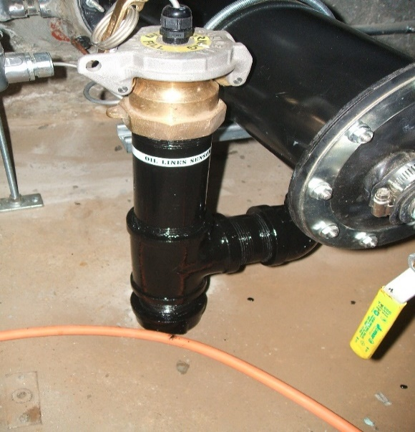
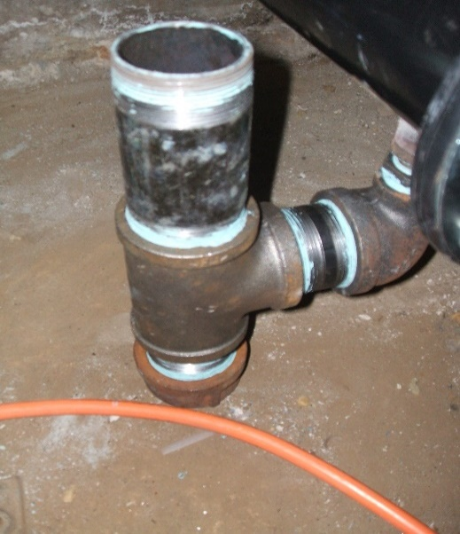
Figure 6.2. Another notable variation for the design of a category 3 system involves a liquid-detecting cable run within the length of the piping interstice.

Figure 6.1. Apparatus in early stages of assembly.

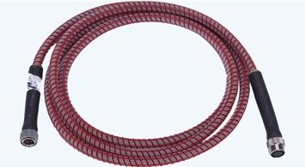
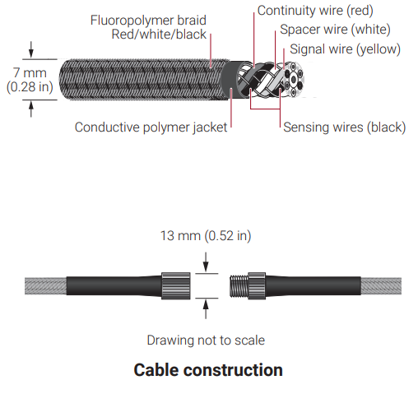
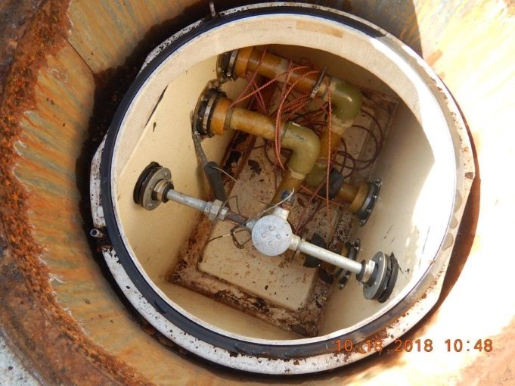
Using Liquid-Detecting Cable Run within the Length of the Piping Interstice
Figure 6.3. TraceTek TT5000 Fuel Sensing cable. Courtesy of Raytech Group Systems.

Figure 6.4. Schematic of cable. Courtesy of Raytech Group Systems.
Figure 6.5. Cable in sump. Courtesy of Tennessee Department of Environment and Conservation.
This example shows components that provide multiple liquid contact points installed within secondary containment areas, for example the containment sump, or a pipe chase surrounding secondary piping. This equipment is available commercially and is used in UST applications. This cable sensor is not reusable and must be replaced once it contacts product.

Section 7. O&M Testing and Inspections Requirements at a Glance

Type of AIM System, Components, and Required Actions  (As Applicable) | Required Testing Frequency | Regulatory Citation | Comments
Categories 1 & 2 Systems
Monitoring console  - Verify system configuration  - Test alarm  - Test battery backup | Annual | 280.40(a)(3)(i) | This can be an ATG or another controller
Sensors  - Test alarm operability for communication with controller | Annual | 280.40(a)(3)(ii) | For all sensors, pressure/vacuum and liquid detecting sensors
Sensors  - Inspect for residual buildup | Annual | 280.40(a)(3)(ii) | For liquid detecting sensors
ALLD  Test and inspect:  - DW piping  - Monitoring reservoir(s)  - Containment sumps at end points | Annual | 280.40(a)(3)(iii) | - The piping interstitial space and the pressure, vacuum, or liquid monitoring reservoir(s) and sensors (pressure, vacuum, or stand-alone liquid detecting sensor, as applicable), and containment sumps at end points, together are the automatic line leak detector.  - Testing of monitoring reservoir and sensors follows vacuum pumps and pressure gauge testing, as noted on table.  - Owners and operators must test their DW piping to verify tightness of the interstitial space. This can be done with a system check.  - Verification of the integrity of the containment sumps at end points is required annually. This could be by testing of the sump or if the sump is DW, proving that the interstitial space of the containment sump has integrity.  - Annual integrity testing of containment sumps at end points that varies from that in 280.35(a)(1)(ii) may be used to test the full area of sumps(s) or area of sump(s) to the point of each sensor’s activation threshold if equipped with liquid detecting sensor(s).
Categories 1 & 2 Systems (Continued)
Monitoring Points (reservoirs and sumps)
Monitoring reservoir  - Ensure proper communication of vacuum pumps and pressure gauges with sensors and controllers | Annual | 280.40(a)(3)(iv) | Verify that the pressure, vacuum, or liquid detecting sensor triggers the alarm at the appropriate threshold and communicates that to the monitoring console.
Containment sumps at end points of category 1 or 2 systems (see example 1.1, 1.2 or 2.1)  - Test containment sumps used for piping interstitial monitoring.  Note: If DW containment sump with periodic monitoring of the integrity of both walls of the sump, sump testing to comply with 280.35(a)(1)(ii) is not required. | Every three years | 280.35(a)(1)(ii) | - As a component of the ALLD, as noted on the table, integrity/functionality of containment sumps at end points must be verified annually. Owners and operators testing annually using a recognized low-level sump testing procedure would meet the regulatory requirement. If the owner and operator use an annual test that varies from what is allowed under 280.35 (a)(1)(ii), then once every three years a test must be completed that complies with 280.35(a)(1)(ii).
Category 3 System
Monitoring console (e.g., ATG or another controller)  - Verify system configuration  - Test alarm  - Test battery backup | Annual | 280.40(a)(3)(i) | ---
Sensors  - Test alarm operability for communication with controller | Annual | 280.40(a)(3)(ii) | For liquid detecting sensors
Sensors  - Inspect for residual buildup | Annual | 280.40(a)(3)(ii) | For liquid detecting sensors
Category 3 System (continued)
ALLD  Test and inspect:  - DW piping  - Area of containment sump(s) to the activation point(s) of the sensor(s)  Note: If DW containment sump with periodic monitoring of the integrity of both walls of the sump, sump testing is not required. | Annual | 280.40(a)(3)(iii) | - The piping interstitial space and the area of the sump(s) used for interstitial monitoring (to the point of each sensor’s activation threshold) and liquid detecting sensors together are the automatic line leak detector.  - Owners and operators must test their DW piping (by air test) to verify tightness of the interstitial space.  - Verification of the integrity of the containment sump is required annually. This could be by testing the sump or if the sump is DW, proving that the interstitial space of the containment sump has integrity.  - Annual integrity test of containment sump that varies from that in 280.35(a)(1)(ii) may be used to test area of sump(s) to the point of each sensor’s activation point.
Containment sump  - Test containment sumps used for interstitial monitoring to ensure liquid tight using vacuum, pressure, or liquid testing. | Every three years | 280.35(a)(1)(ii) | - As a component of the ALLD, integrity/functionality of containment sump(s) must be verified annually. Owners and operators testing annually using a recognized low-level sump testing procedure would meet the regulatory requirement. If the owner and operator use an annual test that varies from 280.35 (a)(1)(ii) then once every three years a test must be completed that complies with 280.35(a)(1)(ii).
For more information on low-level sump testing see the Spill Buckets, Under Dispenser Containment Sumps, Containment Sumps section on EPA’s Underground Storage Tank (UST) Technical Compendium about the 2015 UST Regulation webpage.

Section 8. Basic Test Requirements (by System Component)

General
AIM systems have multiple components. To ensure proper function, evaluate each component as part of the system. Components may be evaluated separately.

EPA recommends inspecting and replacing equipment according to industry-standard code of practice or manufacturer’s specifications.

The components listed below, at minimum, must be tested for proper operation, in accordance with one of the following: manufacturer’s instructions; a code of practice developed by a nationally recognized association or independent testing laboratory; or requirements determined by the implementing agency to be no less protective of human health and the environment that the preceding two options.

Key Components Tested (Annually, Unless Otherwise Noted)
- Monitoring Console
- Sensors
- Double-walled Piping
- Monitoring Points
  - Monitoring reservoirs category 1 and 2 systems: Pressure, vacuum, or liquid reservoirs
  - Containment sumps category 1, 2, and 3 systems

Monitoring Console

Verify system configuration has not changed since the initial piping length and interstitial volume calculations were performed upon system installation. Unless something changed, there is no need to re-calculate pipe length or interstitial volumes. Reference 40 CFR § 280.40(a)(3)(i).

Verify that cell phone and other relay systems, as applicable, respond within the appropriate time. Reference 40 CFR § 280.40(a)(3)(i).

Test audible or visual alarm, or both if console has both, for operability and communication with the monitoring console. Reference 40 CFR § 280.40(a)(3)(i).

Ensure the battery backup system, as applicable, works properly. Reference 40 CFR § 280.40(a)(3)(i).

Sensors

Test all sensors, including pressure, vacuum, and liquid detecting sensors that are part of the monitoring reservoir and standalone liquid detecting sensors in containment sumps for alarm operability and communication with the monitoring console. Reference 40 CFR § 280.40(a)(3)(ii).

Inspect all liquid detecting sensors for residual buildup. Reference 40 CFR § 280.40(a)(3)(ii).

Double-Walled Piping
Note: PEI RP 1200 – Section 5, “Piping Secondary Containment Integrity Testing,” or piping manufacturer interstice integrity testing instructions may be used to meet the automatic line leak detector requirements.
For category 3 AIM systems, perform an integrity test (by air test) of the secondary walls of all double-walled piping of the system, to prove tightness of the interstitial space, at least once every year after installation. This subsequent testing verifies proper piping interstitial communication for the system’s capability to meet automatic line leak detector requirements. Reference 40 CFR § 280.40(a)(3)(iii).

For category 1 and 2 AIM systems, integrity testing of the interstitial space is not required by air test. Testing of the secondary walls of DW piping associated with these systems to verify tightness involves a full system check to ensure vacuum pumps and pressure gauges are operating within the manufacturer’s specifications.

Monitoring Points

For Monitoring Reservoirs
Calibrate and maintain reservoirs, according to frequencies, per manufacturer’s instructions. Reference 40 CFR § 280.40(a)(2).

Ensure proper communication of vacuum pumps and pressure gauges, as applicable, with sensors and a monitoring console. This includes verifying that sensors trigger alarm(s) at the appropriate threshold and communicate the alarm condition to the monitoring console. Reference 40 CFR § 280.40(a)(3)(iv).

For Containment Sumps
Confirm integrity/functionality by testing the containment sumps, including those at end points of category 1 and 2 systems, to meet the ALLD annual testing requirement. The minimum area of testing must encompass containment area bottom and sidewalls up to sensor activation point. Reference 40 CFR § 280.40(a)(3)(iii).
Note: Owners and operators testing their containment sumps annually using a recognized low-level sump testing procedure would meet the regulatory requirements under § 280.35(a)(1)(ii) and § 280.40(a)(3)(iii).

Test containment sumps used for interstitial monitoring of piping every three years to ensure liquid tight using vacuum, pressure, or liquid testing. Reference 40 CFR § 280.35 (a)(1)(ii).

If the containment sump is double-walled with periodic monitoring of the integrity of both walls of the sump, then sump testing to comply with § 280.35(a)(1)(ii) is not required.

Records Maintenance

The results of the annual operations test conducted in accordance with § 280.40(a)(3) must be maintained for three years. At a minimum, the results must list each component tested, indicate whether each component tested meets criteria in § 280.40(a)(3) or needs to have action taken to correct an issue. Reference 40 CFR § 280.45(b)(1).

Written documentation of all calibration, maintenance, and repair of release detection equipment permanently located onsite must be maintained for at least one year after the servicing work is completed, or for another reasonable time period determined by the implementing agency. Any schedules of required calibration and maintenance provided by the release detection equipment manufacturer must be retained for five years from the date of installation. Reference 40 CFR § 280.45(C).

Maintain records of operation and maintenance walkthrough inspections per 40 CFR § 280.36(b), for one year. Records must include a list of each area checked was acceptable or needed action taken, a description of actions taken to correct an issue.

Section 9: Required Documentation from UST System Owners and Operators

Certification of Compliance Form
Owner and Operator Verification to UST Implementing Agency
According to 40 CFR § 280.40(a)(4), UST system owners and operators must provide a method, or combination of methods, of release detection that meets the release detection performance requirements with any performance claims and their manner of determination described in writing by the equipment manufacturer or installer.

There are many variations among individual UST site conditions and system configurations across the United States. This is especially applicable to EPG UST systems. Because of these variations a complete AIM system would have to be manufactured and installed onsite as a unit to meet the release detection method requirements. AIM systems are comprised of several components. No one component manufacturer can verify that applicable regulatory performance requirements can be met for the entire system.

UST system owners and operators can use the Certification of Compliance Form on page 43 to verify that their AIM systems meet design and installation criteria. The form must be signed by the equipment installer, a licensed PE, or other professional required by the applicable UST implementing agency. EPG UST system owners and operators in Indian Country, where the federal UST regulation (40 CFR part 280) applies, may submit this form to the applicable EPA regional office. EPA’s UST website lists the EPA Regional UST contacts.

UST system owners and operators in other jurisdictions should contact their UST implementing agency to determine whether the agency allows the use of an AIM system to meet its regulatory requirements and whether this sample form meets the agency’s documentation requirements. Note that many state UST implementing agencies require UST system installers to be licensed. EPA’s UST website lists state UST contacts.

The checklist below covers testing requirements applicable to AIM systems. This checklist helps owners and operators identify and comply with key operation and maintenance testing requirements associated with AIM systems. This checklist does not include all testing requirements that owners and operators of EPG UST systems must meet. For additional information on meeting federal UST requirements applicable to other equipment and components of EPG UST systems see EPA’s Requirements for Emergency Power Generator UST systems at https://www.epa.gov/ust/publications-related-underground-storage-tanks.
Fillable PDFs of the checklists below are available at https://www.epa.gov/ust/certification-inspections-and-testing-forms-automated-interstitial-monitoring-systems.

Certification of Compliance Form: Use of AIM System for EPG UST Facility (Page 1 of 2)
Facility Name |  | Facility ID #
Physical Address
City | County |  |  |  | State
UST Owner
Installer or PE’s Signature
Printed Name of Installer or PE
Description |  | Line # / Product | Line # / Product | Line # / Product |  | Line # / Product
Line Number / Product
Piping Manufacturer
Piping Model
Pipe Diameter / Length of Pipe |  | / | / | / |  | /
Approximate Pipe Interstice Volume (Gallons)
Type of AIM System (Category #) |  | p 1 p 2 p 3 | p 1 p 2 p 3 | p 1 p 2 p 3 |  | p 1 p 2 p 3
Category 1 or Category 2 Aim Systems
Pressure (P) / Vacuum (V) / Liquid Reservoir Manufacturer
P / V / Liquid Reservoir Model
Note: Some category 1 and 2 systems may also have containment sumps with liquid-detecting sensors like those used in category 3 systems. These sumps may not be monitored by the pressure, vaccum, or liquid reservoirs. These sumps may be needed to monitor single-walled piping components inside the sump. As a containment sump used for interstitial monitoring of piping, these sumps must be tested for integrity once every three years.

Note: Containment sump testing is not required if the containment is double-walled and uses periodic interstitial monitoring that monitors the integrity of both walls of the sump.

Comments

Certification of Compliance Form: Use of AIM System for EPG UST Facility (Page 2 of 2)
Category 3 Aim Systems
Sump Sensor Manufacturer
Sump Sensor Model
Secondary Pipe Open to Secondary Containment Sumps or Collection Point? | p Yes p No | p Yes p No | p Yes p No | p Yes p No
Secondary Containment Sumps
Containment Sump Manufacturer
Containment Sump Model
Automatic Tank Gauge or Monitoring Console
Monitoring Console Manufacturer
Monitoring Console Model
With Alarm | p Yes p No | p Yes p No | p Yes p No | p Yes p No
Alarm
Alarm Manufacturer
Alarm Model
Comments
Attach relevant site diagrams, pictures, as-built drawings, and other supporting documentation, as required by UST implementing agency.

Section 10: AIM Systems Inspection and Testing Checklists

Fillable PDFs of the checklists below are available at
https://www.epa.gov/ust/certification-inspections-and-testing-forms-automated-interstitial-monitoring-systems.

AIM System Inspection and Testing Checklist: Category 1 or 2
UST Facility |  |  |  | Person Completing Checklist
Facility Name |  | Facility ID # |  | Name
Physical Address |  |  |  | Company
City | County |  | State | City |  | State
UST Owner |  |  |  | Signature |  | Date Completed
Description |  | Line 1 |  | Line 2 | Line 3 | Line 4
Type of AIM System (Category #) |  | 1 2 |  | 1 2 | 1 2 | 1 2
Attach a copy of the Certification Form for detailed system description.
Walkthrough Inspections [280.36]
Annual
- Visually check containment sumps at endpoints for damage and leaks to the containment area or releases to the environment. Remove water and debris.
- For double-walled sumps with interstitial monitoring, check for a leak in the interstitial area.
Every 30 Days
- Check that system is operating with no alarms or unusual operating conditions.
- Ensure records of system component testing listed below are reviewed and current |  | p Pass  p Fail |  | p Pass  p Fail | p Pass  p Fail | p Pass  p Fail
Note: The items below are not required to be performed every 30-days as part of the walkthrough inspection. Most items must be performed annually, unless otherwise noted. Use this checklist to verify that each step has been performed within one year (i.e., 365 days) of the previous test, unless otherwise noted. If No is checked for any of the steps, the AIM system fails. Provide copies of all relevant test forms upon request to the UST implementing agency.
Testing (Required Annually - Unless Otherwise Noted)
Monitoring Console 280.40(a)(3)(i)
- Verify system configuration. |  | p Yes p No |  | p Yes p No | p Yes p No | p Yes p No
- Test alarm |  | p Yes p No |  | p Yes p No | p Yes p No | p Yes p No
- Test battery backup |  | p Yes p No |  | p Yes p No | p Yes p No | p Yes p No
Date Last Test
Test Results |  | p Pass  p Fail |  | p Pass  p Fail | p Pass  p Fail | p Pass  p Fail
Sensors 280.40(a)(3)(ii)
- Test alarm operability for communication with controller/monitoring console. |  | p Yes p No |  | p Yes p No | p Yes p No | p Yes p No
Testing (Continued)
Description |  | Line 1 |  | Line 2 | Line 3 | Line 4
- Inspect for residual buildup. |  | p Yes p No |  | p Yes p No | p Yes p No | p Yes p No
Date Last Test
Test Results |  | p Pass  p Fail |  | p Pass  p Fail | p Pass  p Fail | p Pass  p Fail
ALLD 280.40(a)(3)(iii)
- DW piping.  Verify integrity of interstitial space by air testing piping. Ensure vacuum pumps and pressure gauges are operating within manufacturer’s specifications. |  | p Yes p No |  | p Yes p No | p Yes p No | p Yes p No
- Monitoring reservoir.  Note: Testing of this component covered below. Listed to show as part of ALLD. |  | p Yes p No |  | p Yes p No | p Yes p No | p Yes p No
- Containment sumps at end points.  Note: Verification of integrity could be by testing of the sump or if the sump is DW, proving that the interstitial space of the containment sump has integrity. Annual integrity testing of containment sumps at endpoints that varies from that in 280.35(a)(1)(ii) may be used to test full area of sumps(s) or area of sump(s) to the point of each sensor’s activation threshold, if equipped with liquid detecting sensor(s). |  | p Yes p No |  | p Yes p No | p Yes p No | p Yes p No
Date Last Test
Test Results |  | p Pass  p Fail |  | p Pass  p Fail | p Pass  p Fail | p Pass  p Fail
Monitoring Points 280.40(a)(3)(iv)
- Monitoring Reservoir (P / V / Liquid)
- Ensure proper communication of vacuum pumps and pressure gauges with sensors and controllers, as applicable. Verify that the pressure, vacuum, or liquid detecting sensor triggers the alarm at the appropriate threshold and communicates that to the monitoring console. |  | p Yes p No |  | p Yes p No | p Yes p No | p Yes p No
- P / V System Calibrated Per Manufacturer’s Instructions. 280.40(a)(2) |  | p Yes p No |  | p Yes p No | p Yes p No | p Yes p No
Describe calibration completed and frequency:
Testing (Continued)
Description |  | Line 1 |  | Line 2 | Line 3 | Line 4
Containment Sumps at End Points 280.35(a)(1)(ii) – Required Once Every Three Years
- Test containment sumps used for piping interstitial monitoring to ensure liquid tight by using vacuum, pressure, or liquid testing. |  | p Yes p No |  | p Yes p No | p Yes p No | p Yes p No
Notes: If DW containment sump with periodic monitoring of both walls of the sump, sump testing to comply with 280.35(a)(1)(ii) is not required.
Owners and operators testing annually using a recognized low-level sump testing procedure would meet the regulatory requirement. If the owner and operator use an annual test that varies from what is allowed under 280.35 (a)(1)(ii), then a test that complies with 280.35(a)(1)(ii) must be completed every three years..
Date Last Test
Test Results |  | p Pass  p Fail |  | p Pass  p Fail | p Pass  p Fail | p Pass  p Fail
Comments

AIM System Inspection and Testing Checklist: Category 3
UST Facility |  |  |  |  | Person Completing Checklist
Facility Name |  |  | Facility ID # |  | Name
Physical Address |  |  |  |  | Company
City | County |  |  | State | City |  | State
UST Owner |  |  |  |  | Signature |  | Date Completed
Description |  |  | Line 1 |  | Line 2 | Line 3 | Line 4
Attach a copy of the Certification Form for detailed system description.
Walkthrough Inspections [280.36]
Annual
- Visually check containment sumps at endpoints for damage, leaks to the containment area, or releases to the environment. Remove water and debris.
- For double-walled sumps with interstitial monitoring, check for a leak in the interstitial area.
Every 30 Days
- Check that system is operating with no alarms or unusual operating conditions.
- Ensure records of system component testing listed below are reviewed and current – Date of the last test is not beyond 1-year (i.e., 365 days) from the previous test. |  |  | p Pass  p Fail |  | p Pass  p Fail | p Pass  p Fail | p Pass  p Fail
Note: If any of the items below are marked as No, then the AIM system fails. Provide copies of all relevant test forms upon request to the UST implementing agency.
Testing (Required Annually - Unless Otherwise Noted)
Monitoring Console 280.40(a)(3)(i)
- Verify system configuration. |  |  | p Yes p No |  | p Yes p No | p Yes p No | p Yes p No
- Test alarm |  |  | p Yes p No |  | p Yes p No | p Yes p No | p Yes p No
- Test battery backup |  |  | p Yes p No |  | p Yes p No | p Yes p No | p Yes p No
Date of Last Test
Test Results |  |  | p Pass  p Fail |  | p Pass  p Fail | p Pass  p Fail | p Pass  p Fail
Sensors 280.40(a)(3)(ii)
- Test alarm operability for communication with controller/monitoring console. |  |  | p Yes p No |  | p Yes p No | p Yes p No | p Yes p No
- Inspect for residual buildup. |  |  | p Yes p No |  | p Yes p No | p Yes p No | p Yes p No
IM System Inspection and Testing Checklist: Category 3
Testing (Continued)
Description |  | Line 1 |  |  | Line 2 | Line 3 | Line 4
Date of Last Test
Test Results |  |  | p Pass  p Fail |  | p Pass  p Fail | p Pass  p Fail | p Pass  p Fail
ALLD 280.40(a)(3)(iii)
- DW piping.  Test by air test to prove tightness of the interstitial space. |  | p Yes p No |  |  | p Yes p No | p Yes p No | p Yes p No
- Area of containment sump(s) to the activation point of the sensor.  Note: Integrity could be verified by testing the sump or if the sump is DW, by proving that the interstitial space of the containment sump has integrity. Annual integrity testing of containment sumps at end points that varies from that in 280.35(a)(1)(ii) may be used to test full area of sumps(s) or area of sump(s) to the point of each sensor’s activation threshold, if equipped with liquid detecting sensor(s). |  | p Yes p No |  |  | p Yes p No | p Yes p No | p Yes p No
Date Last Test
Test Results |  | p Pass  p Fail |  |  | p Pass  p Fail | p Pass  p Fail | p Pass  p Fail
Monitoring Points 280.40(a)(3)(iv)
Containment Sumps Used for Piping Interstitial Monitoring 280.35(a)(1)(ii) – Required Once Every Three Years
- Test containment sumps used for piping interstitial monitoring to ensure liquid tight by using vacuum, pressure, or liquid testing. |  | p Yes p No |  |  | p Yes p No | p Yes p No | p Yes p No
Notes: If DW containment sump with periodic monitoring of both walls of the sump, sump testing to comply with 280.35(a)(1)(ii) is not required.
Owners and operators testing annually using a recognized low-level sump testing procedure would meet the regulatory requirement. If the owner and operator use an annual test that varies from what is allowed under 280.35 (a)(1)(ii), then once every three years a test must be completed that complies with 280.35(a)(1)(ii).
Date Last Test
Test Results |  | p Pass  p Fail |  |  | p Pass  p Fail | p Pass  p Fail | p Pass  p Fail
Comments

Comparison of Equivalent 3 gph Leaks—Formulas and Rationale

Appendix
Orifice Size for 3 gph at 10 psi Equivalent for Gasoline
Constants used for Orifice Size Calculation
Cd = 0.61 Sharp Edge
SG gas = 0.68 at 60 degrees Fahrenheit
Pw, std = 0.0361 density of water standard
Pressure | Diameter | Area | Flow rate | Flow Rate
psi | inches | in² | in³ / sec | gph
10 | 0.11868 | 0.0111 | 0.19261129 | 3.001734336

Flow Rate (gph) of Air at Constant Pressure through Orifice Volume of Air Discharged at Constant Pressure
Comments
- A pressure drop of 10 psi = approximately 300" water column.
- SG air at 10 psi and 70 degrees F = 1.68 (see The Effect Of Air Pressure On Air on page 20 in the reference Eclipse Combustion Engineering Guide (mathscinotes.com) table).
- SG air at 5 psi and 70 degrees F = 1.34.
Reference for Equation used to Determine Orifice Size:
https://www.lmnoeng.com/Flow/LeakRate.php

Test Pressure | Diameter | Area | Cd | Pressure Differential | Specific Gravity (SG) | Air Flow | Air Flow | Air Flow | Air Flow
psi | inches | in² |  | in WC | Air | ft³ / hr. | ft³ / min | gph | gpm
10 | 0.11868 | 0.0111 | 0.61 | 277.08 | 1.68 | 143.73 | 2.40 | 1075.21 | 17.92
5 | 0.11868 | 0.0111 | 0.61 | 138.54 | 1.34 | 113.80 | 1.90 | 851.30 | 14.19
4 | 0.11868 | 0.0111 | 0.61 | 110.83 | 1.272 | 104.47 | 1.74 | 781.51 | 13.03
3 | 0.11868 | 0.0111 | 0.61 | 83.12 | 1.204 | 92.99 | 1.55 | 695.66 | 11.59
2 | 0.11868 | 0.0111 | 0.61 | 55.42 | 1.136 | 78.17 | 1.30 | 584.76 | 9.75
1 | 0.11868 | 0.0111 | 0.61 | 27.71 | 1.068 | 57.00 | 0.95 | 426.45 | 7.11
0 | 0.11868 | 0.0111 | 0.61 | 0.00 | 1 | 0.00 | 0.00 | 0.00 | 0.00

Reference for Air Flow Equivalent
Source: Eclipse Combustion Engineering Guide (mathscinotes.com)

Application of Boyles Law |  |  |  | P1V1 = P2V2
How much compressed air will a 100 ft³ pipe interstitial volume hold at 5 psi?
P1 = 1 atm = |  | 14.69 | psi
V1 = | 134.04 | ft³ | Volume prior to compression (interstitial volume + ambient air needed)
P2 = 1 atm + | 5 | 19.69 | psi
V2 = | 100.00 | ft³ | Volume after compression (interstitial space volume)
 | 34.04 | ft³ | Volume ambient air added required to reach 5 psi
Explanation: | Pipe interstice volume of 134 ft³ would compress down to 100 ft³ at 5 psi test pressure.
 | The difference, 34.04 ft³, is the volume of air required to bring the pipe pressure up to 5 psi.
 | 34.04 ft³ is the volume of air necessary to bleed off to bring pipe interstice back to 0 psi atmospheric pressure.

Time Required for PEI Air Test
• The volume of loss per loss of 1 psi pressure is consistently 50.9 gallons of air.
• This only applies to a volume of 100 ft3. In other words, it takes 50.9 gallons of air to be compressed to pressurize 100 ft3 for each psi.
• Smaller pipe volumes would require less air loss per psi.
• That is because of the relationship due to gas Equation P1V1 = P2V2.

A Closer Look at Time of Decay for 100 ft3 Pipe Interstice
Test | Initial Atmospheric (At) Pressure |  |  | At Test Pressure |  |  | Cumulative Volume of Air per psi Test Pressure |  |  |  | Air Loss
Pressure | P1 | V1 |  | P2 | V2 |  | Added |  | Lost |  | Per psi
psig | psia | ft³ | gallons | psig | ft³ | gallons | ft³ | gallons | ft³ | gallons | gallons
10.0 | 14.7 | 168.1 | 1257.4 | 24.7 | 100.0 | 748.1 | 68.1 | 509.3 | 0 | 0
9.0 | 14.7 | 161.3 | 1206.4 | 23.7 | 100.0 | 748.1 | 61.3 | 458.3 | 6.8 | 50.9
8.0 | 14.7 | 154.5 | 1155.5 | 22.7 | 100.0 | 748.1 | 54.5 | 407.4 | 13.6 | 101.9
7.0 | 14.7 | 147.7 | 1104.6 | 21.7 | 100.0 | 748.1 | 47.7 | 356.5 | 20.4 | 152.8
6.0 | 14.7 | 140.8 | 1053.7 | 20.7 | 100.0 | 748.1 | 40.8 | 305.6 | 27.2 | 203.7 | 50.9
5.0 | 14.7 | 134.0 | 1002.7 | 19.7 | 100.0 | 748.1 | 34.0 | 254.6 | 34.0 | 254.6 | 50.9
4.0 | 14.7 | 127.2 | 951.8 | 18.7 | 100.0 | 748.1 | 27.2 | 203.7 | 40.8 | 305.6 | 50.9
3.0 | 14.7 | 120.4 | 900.9 | 17.7 | 100.0 | 748.1 | 20.4 | 152.8 | 47.7 | 356.5 | 50.9
2.0 | 14.7 | 113.6 | 850.0 | 16.7 | 100.0 | 748.1 | 13.6 | 101.9 | 54.5 | 407.4 | 50.9
1.0 | 14.7 | 106.8 | 799.0 | 15.7 | 100.0 | 748.1 | 6.8 | 50.9 | 61.3 | 458.3 | 50.9
0.0 | 14.7 | 100.0 | 748.1 | 14.7 | 100.0 | 748.1 | 0.0 | 0.0 | 68.1 | 509.3 | 50.9

Time Required for PEI Air Test (continued)
• The volume of loss per loss of 1 psi pressure is consistently 50.9 gallons of air.
• This only applies to a volume of 100 ft3. In other words, it takes 50.9 gallons of air to be compressed to pressurize 100 ft3 for each psi.
• Smaller pipe volumes would require less air loss per psi.
• That is because of the relationship due to gas Equation P1V1 = P2V2.

A Closer Look at Time of Decay for 100 ft³ Pipe Interstice
Test | Initial Atmospheric (At) Pressure |  |  | At Test Pressure |  |  | Cumulative Volume of Air per psi Test Pressure |  |  |  | Air Loss
Pressure | P1 | V1 |  | P2 | V2 |  | Added |  | Lost |  | Per psi
psig | psia | ft3 | gallons | psig | ft3 | gallons | ft³ | gallons | ft³ | gallons | gallons
10.0 | 14.7 | 168.1 | 1257.4 | 24.7 | 100.0 | 748.1 | 68.1 | 509.3 | 0 | 0
9.0 | 14.7 | 161.3 | 1206.4 | 23.7 | 100.0 | 748.1 | 61.3 | 458.3 | 6.8 | 50.9
8.0 | 14.7 | 154.5 | 1155.5 | 22.7 | 100.0 | 748.1 | 54.5 | 407.4 | 13.6 | 101.9
7.0 | 14.7 | 147.7 | 1104.6 | 21.7 | 100.0 | 748.1 | 47.7 | 356.5 | 20.4 | 152.8
6.0 | 14.7 | 140.8 | 1053.7 | 20.7 | 100.0 | 748.1 | 40.8 | 305.6 | 27.2 | 203.7 | 50.9
5.0 | 14.7 | 134.0 | 1002.7 | 19.7 | 100.0 | 748.1 | 34.0 | 254.6 | 34.0 | 254.6 | 50.9
4.0 | 14.7 | 127.2 | 951.8 | 18.7 | 100.0 | 748.1 | 27.2 | 203.7 | 40.8 | 305.6 | 50.9
3.0 | 14.7 | 120.4 | 900.9 | 17.7 | 100.0 | 748.1 | 20.4 | 152.8 | 47.7 | 356.5 | 50.9
2.0 | 14.7 | 113.6 | 850.0 | 16.7 | 100.0 | 748.1 | 13.6 | 101.9 | 54.5 | 407.4 | 50.9
1.0 | 14.7 | 106.8 | 799.0 | 15.7 | 100.0 | 748.1 | 6.8 | 50.9 | 61.3 | 458.3 | 50.9
0.0 | 14.7 | 100.0 | 748.1 | 14.7 | 100.0 | 748.1 | 0.0 | 0.0 | 68.1 | 509.3 | 50.9

AIM Systems Exceed the 3 gph at 10 psi Equivalent Performance Standard
3 gph standard |  | 2 gph standard |  | 1 gph standard |  | 0.5 gph standard |  | 0.2 gph standard
Air LR | Time | Air LR | Time | Air LR | Time | Air LR | Time | Air LR | Time
GPM | MIN | GPM | MIN | GPM | MIN | GPM | MIN | GPM | MIN
14.19 | 3.59 | 9.45 | 5.38 | 4.73 | 10.77 | 2.36 | 21.53 | 0.95 | 53.82
13.03 | 3.91 | 8.68 | 5.87 | 4.34 | 11.73 | 2.17 | 23.46 | 0.87 | 58.63
11.59 | 4.39 | 7.73 | 6.59 | 3.86 | 13.18 | 1.93 | 26.35 | 0.77 | 65.86
9.75 | 5.22 | 6.49 | 7.84 | 3.25 | 15.67 | 1.62 | 31.35 | 0.65 | 78.36
7.11 | 7.16 | 4.74 | 10.75 | 2.37 | 21.49 | 1.18 | 42.99 | 0.47 | 107.44
0 | 0 | 0 | 0 | 0 | 0 | 0 | 0 | 0 | 0
Sum | 24.27 |  | 36.43 |  | 72.84 |  | 145.68 |  | 364.12

• Sum is the total time required for test pressure to drop from 5 psi to 0 psi.
• Air leak rate came from calibrated orifices on previous sheets. Same logic. 3 gph at 10 psi gas leak, these would be 2 gph at 10 psi leak equivalent, etc.

This indicates:
• For an interstitial space volume of 100 ft³, the PEI RP 1200 test would easily detect down to a 1 gph standard.
• It would drop from 5 psi to 1 psi within 1 hour on the gauge.
• 0.5 gph and 0.2 gph calculations here are not equivalent to what we traditionally think of as a 0.5 or 0.2 gph leak rate, respectively.
• Figures are based on a hole sized 0.2 gph at 10 psi, which will not be the same as the traditional set 0.2 gph leak rate. Should be a smaller hole size depicted here because of the 10-psi pressure.
• For the 0.5 and 0.2 gph leak rate, gauge reliability is extremely important.
• For example, for the 0.5 gph leak rate, the test pressure would drop from 5 psi to near 2.5 psi.
• For the 0.2 gph leak rate, the best-case scenario is an observer would see the gauge drop from 5 psi to 4 psi within 1 hour.
• Selecting a lower maximum pipe volume (instead of 100 ft³) would produce better results here, but keep in mind these are based on 0.2 gph at 10 psi in-line pipe pressure.
• Picking a maximum pipe volume of 500 gallons, for example, would notably improve the results for 0.5 and somewhat enhance 0.2 results, but likely won't result in a significant drop in pressure within 1 hour. Reducing it further would improve 0.2.

