Combined Air Emissions Reporting System

Roadmap for SLT Partner Onboarding
Version 2 as of 11/07/2022

Introduction
This document provides the general steps that a state, local, or tribal (SLT) authority will follow to adopt the Combined Air Emissions Reporting System (CAERS). It covers onboarding steps starting from an SLT’s initial consideration to participate in CAERS, through work with EPA to adopt CAERS for reporting, and up to the time facilities use CAERS for live air emissions reporting to the NEI, TRI and SLT air programs. In this document, all these steps are referred to as the “onboarding” process. The use of CAERS is not mandatory for SLTs. However, SLTs may find it beneficial to adopt CAERS, and the ongoing collaboration with current and future SLT partners will ensure that CAERS is updated and improved over time.
All SLT authorities that are potentially interested in onboarding with CAER in the future are encouraged to start thinking about the timing for that work by reviewing this document. Because not all aspects of adoption and customization specific to your SLT may be covered in this version of the document, SLTs should feel free to reach out to the CAER Product Design Team (PDT) co-chairs to ask questions to determine if and how adopting CAERS may benefit them: Julia Gamas (gamas.julia@epa.gov), Tammy Manning (tammy.manning@ncdenr.gov), or Stacy Knapp (stacy.r.knapp@maine.gov). SLTs may also reach out to Kurt Rakouskas from ECOS with questions (krakouskas@ecos.org). Once your SLT staff have determined that you would like to start reporting using CAERS for a specific inventory year, you should let one of the PDT CAER co-chairs know as soon as possible to get the process started.
As with CAERS development itself, onboarding for SLTs follows the Agile paradigm. SLT-specific requirements will be gathered, deployed, and tested progressively, allowing for the resolution of emerging issues before the system is actively used by an SLTs regulated community. CAERS is being designed as a shared service, and while each SLT has unique needs, many SLTs may have similar requirements. As an attribute or piece of functionality is built for one or more SLTs, new onboarding SLTs will be able to take advantage of that functionality. Thus, it is recommended that an SLT obtain a test account as soon as possible so it may find out what functionality in CAERS already exists, and what functionality it would still need before adopting CAERS.
While EPA works closely with SLTs during the onboarding process, the work will not stop there. Beyond the onboarding period, the CAER team will continue to support onboarded SLTs by adding enhancements to CAERS. Therefore, periodic check-ins with SLTs and their facilities will continue past the onboarding phase. Feedback obtained from these check-ins will be prioritized and implemented towards continuous improvement of CAERS as time and resources permit.
Over time, CAERS will include several different workflows to support the different needs of participating SLT authorities, and as this happens, SLTs may decide to use CAERS instead of their custom system. Early in the CAERS requirements gathering phase it became evident that, broadly speaking, there are four cases for how SLTs might use CAERS, depending on whether they wish to keep their current air emissions reporting system. See Appendix 1 for a description of each Case. You should identify which Case applies to your SLT, as this will determine the amount of time and resources you may need to devote to adopting CAERS. For example, the steps and timeline to onboard a SLT that does not currently have its own reporting system and would like to adopt CAERS “as is” will be different than those for an SLT that wishes to take advantage of CAERS while maintaining some or all of its current custom reporting system.
Note that we already have Case 4 and 3 SLTs using CAERS, and we are currently working on creating the webservices that will allow Case 2 SLTs to onboard. In future, we hope to expand so that Case 1 SLTs may also use CAERS. If your SLT falls in the category of Cases 3-4, it will be easier for you to adopt CAERS, because we have already worked with an SLT similar to yours and we have already built the basic workflow for that Case in CAERS.
Trainings on CAER website will help SLTs learn what CAERS already offers. Interested SLTs may also request a live demo of CAERS, including the SLT reviewer side of the application, by reaching out to one the co-chairs, or the ECOS POC, as listed above. CAERS training for SLTs will be posted at a future date. You should reach out to one of the co-chairs listed above to obtain access to that training.

Timing and Resources
In addition to any resources the SLT may have, SLTs may want to look into applying for a grant at the EPA Exchange Network Grants Program, by referring to the “Exchange Network Grant Program Solicitation Notice”. Other resources may also be available through the Environmental Council of States (ECOS), point of contact: Kurt Rakouskas.
Table 1 provides an example timeline of work for an onboarding SLT, but EPA will work with individual SLTs, and their specific timelines as needed. Each phase will be explained in Section 3. Key milestones of the timeline include the SLT emissions reporting deadline in any given year (which varies among SLT agencies), the TRI reporting deadline of July 1st, and the NEI reporting deadline for SLTs of December 31st. Starting with CAERS V3, released in February of 2022, new releases of CAERS will continue to be deployed starting early February of each year. However, SLTs may choose to start their annual reporting in CAERS later in the year if desired. The reader should keep in mind that an SLT wishing to onboard to CAERS “as is” will have less preliminary work to do to start using CAERS than an SLT who does not wish to onboard with CAERS until a certain set of enhancements or customizations have been incorporated, and/or a workflow between CAERS and the SLTs custom system has been designed, built, and deployed.
Table 1. Example timing for SLT onboarding process
Project Phase | Months before SLT Target Reporting Deadline to its Regulated Community | Example for an SLT Reporting with a June 2025 Reporting Deadline for Inventory Year 2024 Data
Phase 1: Assessment of Assets and Needs | 24 to 19 | October to December 2023 if going live February of 2025
Phase 2: Requirements Gathering | 18 to 14 | By January to April 2024 if going live February of 2025
Phase 3: Development and Testing | 13 to 8 | By May to November 2024 if going live February of 2025
Phase 4: Final Testing & Communication towards Live Reporting | 2 | December to January 2024 if going live February 2025
Phase 5: Deployment |  | February to June 2025

Phase 1: Assessment of Assets and Needs
CAERS is being designed to assist SLTs and the regulated community in streamlining air emissions reporting by allowing for data to be shared among federal and SLT systems where applicable. Currently facilities can create annual emissions inventory reports and SLTs can review them, all within CAERS, so that the SLT may send annual reports to EIS directly from CAERS. CAERS is also able to add up any toxics reported there and leave them for TRI-MEweb to pick up. This helps the facility use data already reported in CAERS instead of having to re-enter it in TRI. This workflow is being further refined. In future, however, CAERS will also have workflows with CEDRI, to allow for stack test data that has been reported in CEDRI to be used as a calculation method in CAERS. We are also exploring allowing Greenhouse Gas Reporting Program (GHGRP) data to be shared with CAERS to avoid double entry of facility, sub-facility, unit, and process information (e.g. process type and throughput) where shared with GHGRP. In addition, SLTs have their own requirements that may be different than those for the federal programs, and CAERS has been designed to allow SLTs to create customized modules so they may collect additional data they need and that can be collected while industry is creating annual reports.
SLTs may want to consider the benefits to them and the regulated community of adopting CAERS. The following list of questions can help a SLT agency assess its needs and existing resources, so that a more detailed and customized plan can be developed jointly with EPA, should they find that adopting CAERS would be of benefit to them.
- How will your SLT benefit from using CAERS? What are the benefits as compared to your current reporting process or system? What are additional dependencies in your agency or authority that could benefit from CAERS (e.g., data availability and easy data retrieval for analyses, interfacing with permitting data)?
- Does your agency collect additional required pollutants and/or other data fields to what the federal programs require? If so, how should those requirements be prioritized?
- Does your agency allow pollutants to be voluntarily reported? If these are hazardous air pollutants (HAPs), do they overlap with Toxics Release Inventory (TRI) pollutants?
- How would you want to participate in CAERS? For example, are you still doing paper reporting and want to move to an electronic system, or would you prefer parts of the CAERS to similar part(s) of your current system, or would you want to keep your system entirely but still take advantage of combined reporting (what Case your SLT falls under will help answer this question, see Appendix 1).
- Who and how many staff people would have time and resources to work with EPA staff on a regular basis (typically an hour on the phone every two weeks), ad hoc meetings when needed, participation in biweekly calls on the PDT if possible, and additional time to help:
  - Find “pilot” facilities in your state who would be willing to do testing during development
  - Gather reporting requirements for your agency (both agency users and facility users) not already in CAERS
  - Support both the policy aspects and the IT aspects; the latter applies when your agency intends to keep part or all of its existing IT system
  - Test CAERS
  - Curate data before reporting begins.
- Are there specific times of the year when you could participate more? Are there times when you’d be less available given other priorities for your agency?
- What kinds of resources/assistance would you not be able to provide?
- Do you need IT resources to be able to support your agency’s use cases for the CAERS?

Phase 2: Requirements Gathering and Fulfillment

SLT Requirements Gathering
In this phase, the team, composed of SLT and EPA staff and contractor, will compile the SLT agency requirements so that they may be prioritized and incorporated in CAERS. While the requirements for the NEI and TRI are already in CAERS, in this phase, any additional requirements that the SLT agency may have for its own program, and that aren’t already in CAERS, are gathered.
It is recommended that the SLT consult the CAER website to see the work the PDT has already done in terms of SLT requirements gathering, over the last several years. This information will help the SLT understand the types of questions that EPA will have and may help the SLT see which of the items required may already be in CAERS, that the SLT can verify during testing.
It is also recommended that even if the SLT has not decided to use CAERS, that you review currently available CAERS trainings. These can be found on the CAER website. Trainings will help SLT staff gather information about what functionality is already in CAERs, learn which of the SLTs requirements may already be available, and think about ways CAERS could provide any additional requirements (e.g., via SLT-specific QA checks).
During this phase, you should gather information as follows:
SLT Data Requirements:
- Facility inventory data management:
  - How does the SLT manage facility inventory data, what systems and/or databases does the SLT draw on to update and maintain its facility inventory?
  - How does the SLT manage facility component ID’s (e.g., unit, process, controls, release points)?
  - Are there additional facility-related data fields the SLT needs to collect during reporting?
- Emissions inventory data management:
  - What is the SLT’s emissions inventory data review and management process?
  - Are there additional pollutant or other emissions-related data fields to the federal programs that the SLT needs to collect during reporting?
- Which SLT agency data system may need to connect with the CAERS?
- What quality assurance and quality control checks, specific to the SLT agency, are needed but are not already in CAERS?
- Are there special/atypical reporting situations that need to be addressed in CAERS?
- What Confidential Business Information (CBI) policies and procedures does the SLT have? CAERS does not handle CBI, rather, the agreement with the PDT is that the SLT discusses the rare instances of CBI with the facility and then directs the facility to enter annual data in a certain way to avoid CBI disclosure.
- What is the SLTs reporting deadline? When would it need facilities to begin reporting and by when should they be done with their reports?
SLT Information Technology Requirements (apply if the SLT agency has an electronic reporting system they wish to keep using):
- How should CAERS interact to obtain and send data to the SLT system? Currently, direct data retrieval from CAERS to the SLT system is under design.
- What is the expected data flow and implications for system-to-system communication (e.g., webservices)?
- What is the right timeline for system interfacing and testing? If the SLT has an Exchange Network Grant, the timing may be particularly relevant to the deadline for using those funds.

EPA IT Requirements Fulfillment
In this phase, the SLT will be required to fill out a CROMERR compliance application specific to the use of CAERS. For CROMERR compliance, EPA will need to know how the SLT gathers information on who the preparers and certifiers will be in CAERS. The SLT will be provided forms to fill out to this effect and “Rules of Behavior” to sign. More information on CROMERR, including a CROMERR training, can be found in the EPA CROMERR site “Overview for State, Local, and Tribal Governments”. SLTs will have the opportunity to ask questions and receive guidance from CROMERR experts at EPA during this process. If you plan to onboard with CAERS, even if this is several months in the future, you are encouraged to start the CROMERR as early in the process as possible to allow for 180 days of review the process may take, after complete materials have been submitted, to ensure you can start using CAERS on your timeline. Please notify Julia Gamas (gamas.julia@epa.gov) when you are ready to begin this process so that the EPA CAERS team can track progress of the application with you.

Phase 3: Development and Testing
During this phase, SLT agency requirements will be incorporated into CAERS, noting that requirements should always be prioritized and ranked, according to “must have” (e.g., program requirements) versus “nice to have” (e.g., enhancement features that the SLT would like but that does not seriously hinder the SLT’s work or ability to meet its requirements).
In this phase, it is important that the SLT obtain a test account so that it may be able to follow progress with CAERS as new functionality is deployed and test it. This gives SLT staff an opportunity to provide feedback on CAERS. SLT staff will meet with EPA periodically to discuss new functionality, bugs, and suggested enhancements, to improve CAERS functionality. Other onboarded and interested SLTs will also be providing input during this time period, and to the degree possible, feedback sessions will be in coordination with these other SLTs.
The SLT should also identify 5-10 facilities for which data should be brought into the CAERS test environment from EIS. In addition, it may be very helpful to enlist the assistance of 5 or more pilot facilities whose reporters would be willing to begin using CAERS in the test environment to provide end-user feedback during the development phase. Criteria for selection will be discussed at the time and given needs and priorities by the SLT. Facility input will be invaluable throughout the process. So long as the facility requests do not interfere with any SLT or federal program requirements, the application will be improved according to this feedback. Any feedback from industry will be obtained through and in coordination with the SLT.
CAERS will provide the facilities with their previous year report, and facilities will edit that report. Unless a facility is brand new and must set up an entirely new report itself, providing the facilities with a starting point will help them navigate the learning curve that will inevitably follow as they learn the new system. Thus, in addition, having the SLT review its data in CAERS is of great benefit because it will allow the SLT to identify actions it may want to take to curate its data in EIS before it is pulled into CAERS. By doing so, it will help facilities be set up to succeed with CAERS reporting by providing them with a good starting point. By testing data for previous year reports in CAERS the SLT will be able to identify issues such as:
- Missing data must be added, or data that was entered incorrectly in EIS in the past needs to be corrected. This gives the SLT the opportunity to make corrections in EIS before pulling the data that the facilities will use to start their reports in CAERS.
- Data needs to be updated (e.g., units of measure that may be outdated).
- A determination needs to be made of which facilities and/or reporting years should be pulled into CAERS:
  - While CAERS will present the facility with the last report that was submitted to EIS, the SLT will need to indicate back to what year it would want to pull in previous year reports. For example, if the facility hasn’t reported in many years, back to what year would you want to allow a previous year report for such facilities? E.g., for inventory year 2023 you notice that a facility’s last report was 2014, you will want to know if pulling data into EIS back from 2014 is still helpful, and/or if that facility is no longer reporting, should be just marked as “Permanently Shutdown” in EIS and not pulled into CAERS at all. It is always easier to not bring them into CAERS than bringing them in then having to delete them.
  - The SLT may want to mark any facilities no longer meeting the reporting thresholds as “ONRE” in EIS so that they aren’t included in CAERS. E.g., a facility’s status has changed from Title V major to a minor source, and it won’t be reporting an EI in future.
- A determination needs to be made regarding if and how to bring controls data into CAERS if the SLT has not configured the data using control paths. E.g., if there is only one control for the facility it might be easier to pull the data in as is, and have the facility add the control to a path, but for complex controls (more than one, in series, parallel, or a mix) the SLT may want to let the facility configure the controls “from scratch” rather than provide the coders with a rule that may or may not work for every situation.
- SLT needs to decode if it wants to bring into CAERS any facility components that have been marked as “Permanently Shutdown”.
Of great value to the onboarding SLT in testing, is running the QA checks that facilities will encounter during their reporting. CAERS will issue both critical errors that won’t allow their report forward, and it will also issue warnings which the SLT reviewer will be able to see once the facility has submitted the report, alerting the facility reporter and SLT reviewer to issues that may or may not be problems. By running the QA checks in the CAERS test environment, the SLT will be able to see the range of issues that may be coming with the data, and will be able to decide what it wants to correct or change in EIS, and what items it will let its facilities edit themselves: For example, here are scenarios where testing in CAERS early before pulling data into the CAERS live production environment can save the SLT and its facility reporters a lot of work later:
- Some facilities have not updated their units of measure (UOMs) in a very long time. Since only changes to the facility and emissions inventory were being sent into EIS, these outdated units of measure have persisted in EIS. When the data comes into CAERS from EIS, many facilities find they have to update the UOMs.
- Some reporters simply relabeled their facility inventory component IDs over time (e.g., units, process IDs are changed), but if they did not alert the SLT to this fact, the SLT has been sending the data into EIS with new IDs. EIS adds any components with new IDs as new, thus, creating additional components, rather than replacing them. Thus, when the facility’s data are pulled into CAERS, their facility inventory looks much bigger than it really is. The facility reporter will have to mark the duplicates as “Permanently Shutdown” to avoid having the duplicates persist in their facility’s inventory.
If you would like a test account, please email Julia Gamas (gamas.julia@epa.gov) with your request so you may begin testing as soon as possible.

Phase 4: Final Testing & Communication towards Live Reporting
In this phase, building out functionality for facility reporters takes a back seat to testing and fixing any remaining coding bugs that may have appeared in the software. The goal of this phase is for CAERS to be ready for redeployment for the next reporting cycle. For SLTs that have data systems that will connect with parts of CAERS, this phase will include final testing with agency and facility pilot users to ensure data systems are working together for a positive user experience.
As work moves towards the next phase, the SLT will assist in developing a plan for communication with all its facilities that will be using CAERS for live reporting. This will include a schedule for demos and trainings to the SLT’s regulated community. Activities in this phase include:
- Webinar to introduce facilities to CAERS, and answer their questions and concerns.
- EPA provided training of facilities in the use of CAERS. It must be noted that onboarded and onboarding SLTs are given the opportunity to review and comment current training materials so they may be updated. By taking this feedback into consideration, the trainings are better tailored to the SLT’s industry needs. E.g., highlighting specific aspects of CAERS that may be different from the reporting system the regulated community is used to may help them learn CAERS faster and with less confusion.

Phase 5: Deployment
Once CAERS is working for your agency, you will be doing the regular work of your emissions collection in a new way. Facilities will be submitting emissions data and SLT agency staff will be reviewing the collected data and working with facilities to resolve any data issues. To support these efforts, EPA will assist the SLT with the following:
- A central CAER help desk will be available for both SLT and facility users. The help desk can assist users on how to use CAERS itself.
- The help desk will relay to the SLT any program-related questions. Facility reporters are also encouraged, during trainings, to reach out to the SLT when they have questions of this kind, as the help desk is not an advisor on the content of a report.
- SLTS will reach out to EPA for assistance with:
  - Any problems they may encounter with CAERS to the development team, and the CAER team will resolve problems as needed. The EPA and SLT agency will communicate regularly on progress and resolution of problems. E.g., a user encounters an error screen that should not be appearing and is probably a bug in the system.
  - Any federal program related questions that the SLT needs help with
- Any issues that neither the help desk, nor the SLT can resolve are turned over the EPA CAER team for resolution. E.g., a user has a complex controls configuration and the SLT would like advice on the best way to enter that information in CAERS.
While reporting is ongoing, the coding team will be addressing any bug fixes that may arise, as well as continuing to work on enhancements that allow the SLT reviewers themselves a more streamlined review process.

What’s Next
To start the onboarding process with CAER, here is what you need to do next:
- Determine which Case your SLT falls under.
- Identify an SLT point of contact for policy and IT issues.
- Contact one of the CAER co-chairs listed in the Introduction section above for a demo, test account, and/or to discuss onboarding.
- The CAER team will reach out to you to start talking about the items listed in Phase 1 and set you up with a test account.
We are looking forward to working with your agency in this exciting phase of the CAER project.

Appendix: SLT Emissions Inventory Reporting System Cases and CAERS Adoption

The following four cases illustrate different SLT authority needs and thus, represent possible tracks for onboarding SLTs to follow depending on whether they would like to keep their current custom (including SLEIS) reporting systems in part or in whole. As SLTs from each of these cases become CAERS users, other SLTs in the same case will find the onboarding process easier. Even so, there may be specific requirements that each SLT will have that is different from other authorities. EPA will work to be as flexible as possible to accommodate these needs.

Case 1: the SLT retains its custom reporting interface and backend and CAERS receives data from the state interface. Data goes to the SLT first. Air toxics data coming from the SLT allows alignment of NEI and TRI data for a given facility. The direction of the workflow between CAERS and CEDRI and GHGRP is still to be determined. Under this Case it is also possible for the SLT to send the data to EIS and have EIS send it to CAERS for distribution to TRI.

Figure A 1 CAERS Workflow for a Case 1 SLT

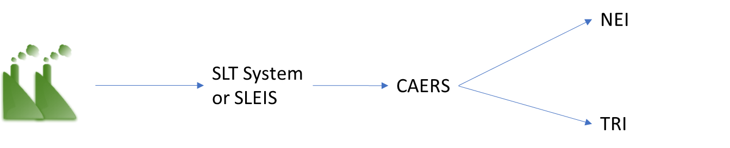

Case 2: the SLT retains its custom reporting interface and backend and CAERS pushes data to the SLT interface. While the SLT could receive the data at the same time as EPA, this workflow can take advantage of the opportunity for data to be aligned amongst federal and state programs by reviewing the data prior to sending it to EPA from CAERS. The direction of the workflow between CAERS and CEDRI and GHGRP is still to be determined.

Figure A 2. CEF Workflow for a Case 2 SLT
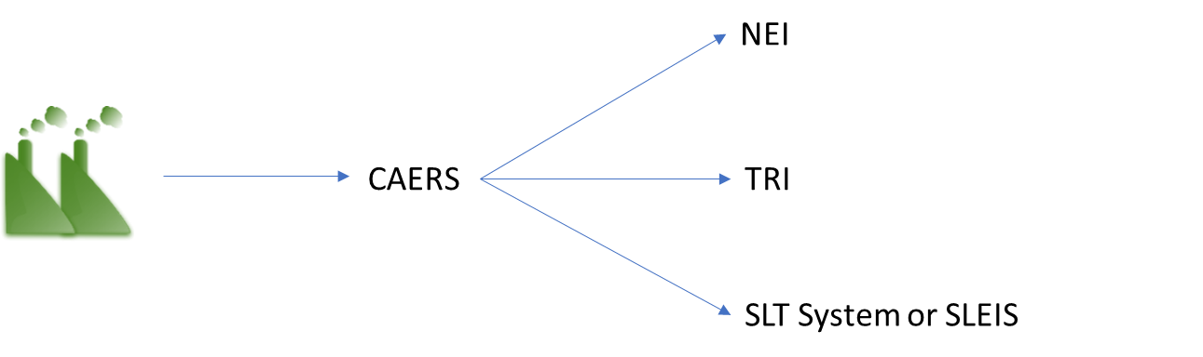

Case 3: CAERS replaces the SLT custom reporting interface but the SLT database is retained. The SLT may review the data in CAERS or its own system prior to sending it to NEI. This workflow takes advantage of the opportunity for data to be aligned amongst federal and state programs. The direction of the workflow between CAERS and CEDRI and GHGRP is still to be determined.

Figure A 3. CEF Workflow for a Case 3 SLT
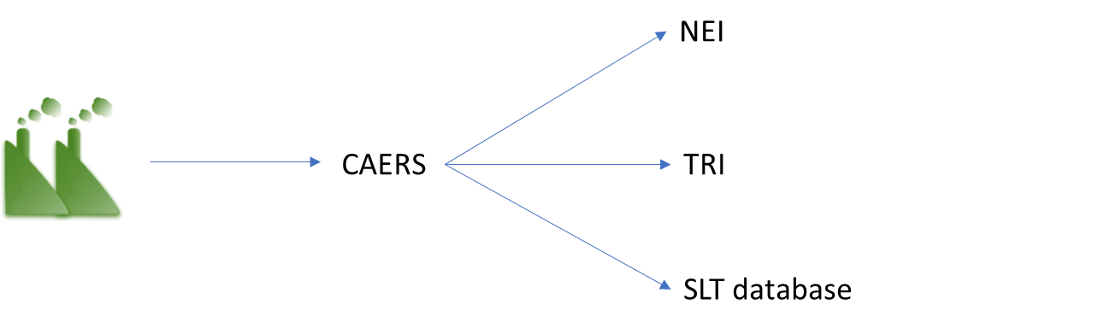

Case 4: The SLT uses CAERS. It either doesn’t have a system of its own or doesn’t wish to keep its current system. In this case the SLT reviews data in CAERS and signs off prior to it reaching EIS. The SLT has the data available for retrieval for its own program if needed. The direction of the workflow between CAERS and CEDRI and GHGRP is still to be determined.

Figure A 4. CEF Workflow for a Case 4 SLT
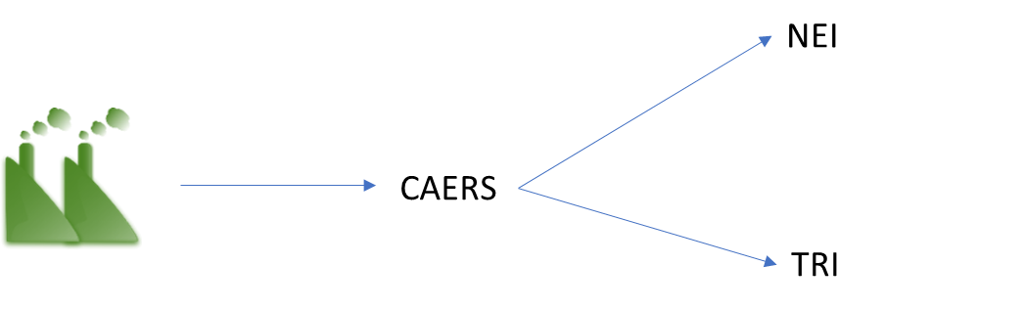

The Air Emissions Reporting Rule (AERR) requires carbon monoxide, nitrogen oxides, volatile organic compounds, sulfur dioxide, ammonia, PM less than 2.5 micros in diameter, PM less than 10 microns in diameter, and lead. The Toxics Release Inventory (TRI) requires specific air toxics and there may or may not be overlap with hazardous air pollutants that the SLT may be interested in.

