General Requirements for Establishing a Tribal CASTNET site
EPA will continue to expand CASTNET’s monitoring partnership with Tribal Nations, as funding allows. Tribes that operate CASTNET sites have realized many benefits including building capacity, expanding monitoring capabilities, engagement with the local community on environmental impacts, and hands-on educational opportunities. This document briefly describes the steps required for establishing a new Tribal CASTNET site.

Interest and Capabilities
Tribes interested in establishing a new CASTNET monitoring site should work with their EPA Regional Tribal Air Coordinator (TAC) to address the following requirements:
- A brief description of how the Tribe will use the air quality and/or deposition data,
- A dedicated air technician that will be available to change out the filter pack weekly and perform other routine site maintenance,
- An accessible location that meets CASTNET siting criteria with a description of any existing infrastructure (e.g., concrete pad) and utilities (e.g., power drop), and
- Concurrence from the EPA Region if Tribal STAG or other grant funding will be held back to support the equipment costs and/or operation of the monitoring site.
The EPA Regional TAC will work with the CASTNET Program to assess the Tribe’s needs and determine if the proposed site would provide benefit to the nation’s air monitoring program (e.g., filling a spatial gap in the network).

CASTNET Site Options
There are three types of CASTNET sites: full site, small-footprint site, and a small-footprint site with ozone.

Full CASTNET Site
A full CASTNET site generally has a walk-in, temperature-controlled shelter. These sites typically include a 10-meter tilt-down tower for the CASTNET filter pack, an ozone analyzer and ozone transfer standard, a temperature probe, mass flow controller, a laptop, and a data logger. Most CASTNET sites in the network include the temperature-controlled shelter, however due to the initial cost of the shelter and the burden of installing the shelter in remote locations, EPA has transitioned to the small-footprint sites for the most recently established sites.
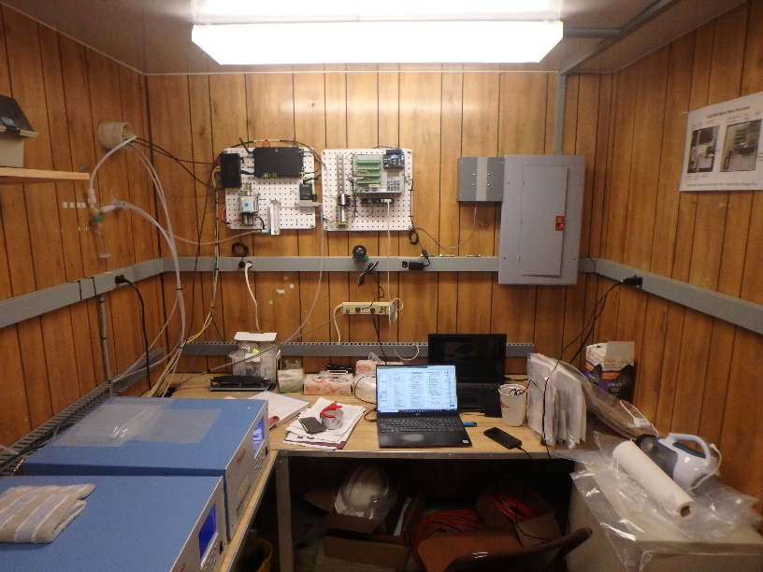
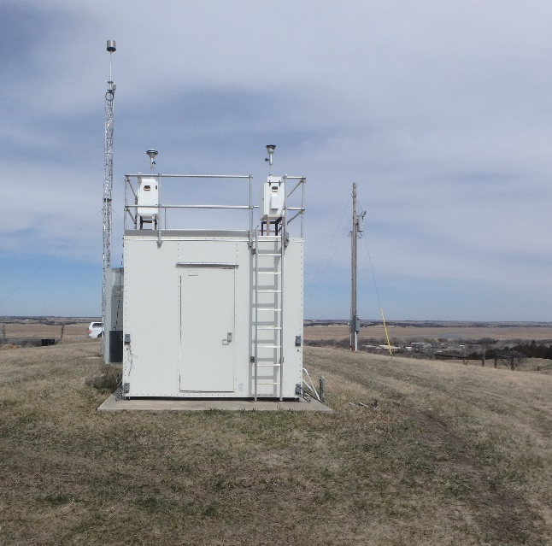
Figure 1 (left) Santee Sioux (SAN189) CASTNET site. Full site includes a temperature controlled, walk-in shelter and a 10-m tilt-down tower. At the top of the tower there is a rain shield that protects the filter-pack and ozone inlet. A temperature sensor is located on the tower. (right) Inside a CASTNET walk-in shelter with the data logger and other communication equipment mounted on the back wall. The ozone analyzer and transfer standard are located on the desk.

Small-Footprint Site
A small-footprint site includes a 10-meter tower for the CASTNET filter pack, a temperature probe, and a small enclosure on the tower to house the data logger, mass flow controller, and pump. These sites are more cost-effective to install and maintain. Several CASTNET locations operate the small-footprint site.
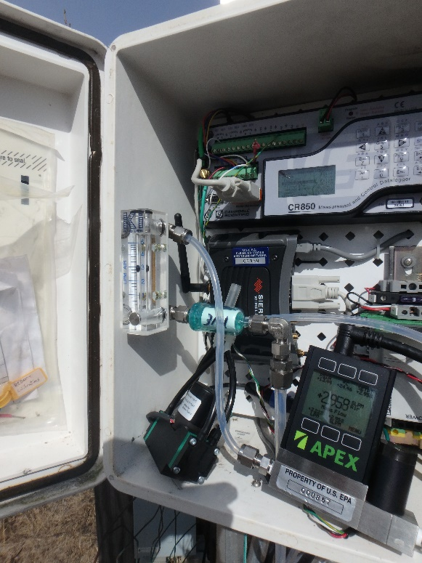
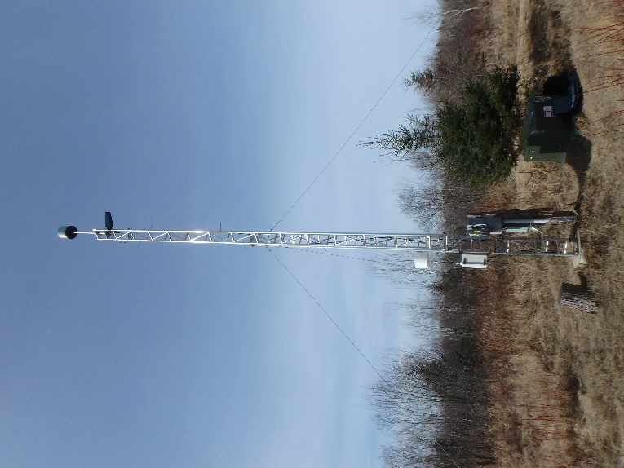
Figure 2 Small-footprint filter pack only site operated by Red Lake Nation (RED004). (Left) 10-meter tilt-down tower with the rain shield protecting the filter pack. Also shown in the NADP/AMoN sampler housing and the small enclosure for the mass flow controller and data logger. (Right) Inside the enclosure used to hold the mass flow controller and data logger.

Small-Footprint Site with Ozone
This small-footprint site includes everything described for a small-footprint site above, but also includes a temperature-controlled enclosure placed near the tilt-down tower to house the ozone analyzer and the transfer standard.
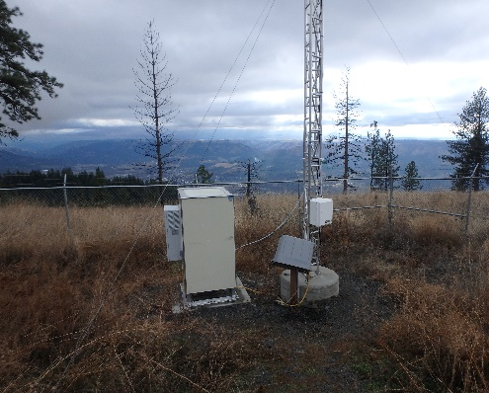
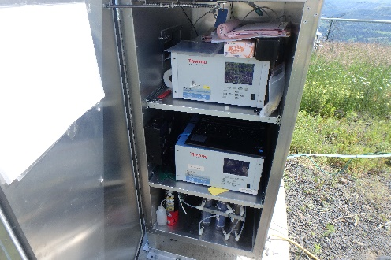
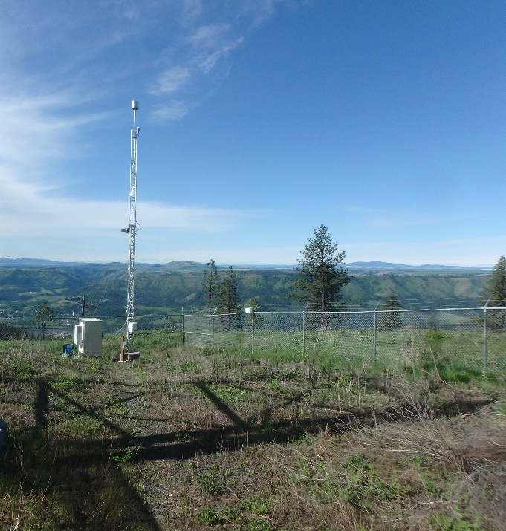
Figure 3 Small footprint site with ozone. (Left) Site includes the 10-meter tilt down tower and a small temperature-controlled enclosure. (Right) inside the temperature-controlled enclosure. The ozone analyzer and transfer standard are mounted inside the enclosure. The ozone inlet is in the rain shield on top of the 10-m tower.

Siting Criteria
CASTNET follows the siting criteria requirements in 40 CFR Part 58 Appendix E and the CASTNET Quality Assurance Project Plan (QAPP). The EPA and the CASTNET contractor will work with the Tribe to identify a location that is accessible, secure, and meets the siting criteria requirements listed in Tables 1 and 2. For more detailed information on siting criteria refer to the CASTNET QAPP on the website.
Table 1 CASTNET siting criteria established to provide a regionally representative signal
Regional Siting Criteria
Potential Interferant | Minimum Distance from Measurement Apparatus
Large point source of SO₂ or NO_{x} | 20 to 40 km
Major industrial complex | 10 to 20 km
City, > 50,000 population | 40 km
City, 10,000 to 50,000 population | 10 km
City, 1,000 to 10,000 population | 5 km
Major highway, airport, or rail yard | 2 km

Table 2 Onsite criteria as required by 40 CFR Part 58 Appendix E or the CASTNET program managers to prevent interferences from obstructions or objects that would impact ambient concentrations
Onsite Criteria (Distance to Sensor or Inlet)
Criterion | Filter Pack and Gas Monitoring
Distance from tree dripline | ≥10m from dripline
Obstacles to wind | 2x obstacle height above inlet
Inlet clearance | Unrestricted airflow arc of 270 degrees
Feedlot operations | 500 m
Intensive agricultural operations (including aerial spraying) | 500 m
Limited agricultural operations | 200m
Large parking lot | 100 m
Small parking lot | 50 m
Filter Pack and Gas Monitoring – Traffic Volume Criteria
Roadway Average Daily Traffic* (vehicles/day) | Minimum Distance for O₃ Monitoring (meters)
≤ 1,000 | 50
10,000 | 100
15,000 | 150
20,000 | 200
40,000 | 300
70,000 | 500
≥ 110,000 | 1,250
*Measured or modeled traffic volumes and miles or approximations based on nearby similar roads

Measurements
CASTNET uses a 3-stage filter pack to measure ambient concentrations of gases and particles. These concentrations are used to assess regional and local air pollution as well as long-term trends in concentrations and atmospheric deposition. CASTNET ozone measurements are used to assess compliance with the National Ambient Air Quality Standards (NAAQS). CASTNET reports the ozone concentrations near-real time to AIRNow and submits both ambient concentrations and audit results to EPA’s Air Quality System (AQS) database.
Most CASTNET sites also include a National Atmospheric Deposition Program (NADP) Ammonia Monitoring Network (AMoN) site to provide a more complete total nitrogen budget. These sites utilize a passive sampler to measure gaseous ammonia concentrations, a contributor to PM2.5 formation. Network partners are also encouraged to consider installing a wet deposition site (NADP’s National Trends Network [NTN]) to complement the dry deposition results provided by CASTNET. EPA will also assist Tribal partners in establishing a NADP mercury site (Mercury Deposition Network [MDN] and/or Mercury Litterfall Network).
Many CASTNET sites also include supplemental measurements that meet the Tribe’s data needs (e.g., PM2.5, aeroallergens) or they participate in Agency research studies (e.g., PFAS in wet deposition).

Network | Measurement Method | Pollutant(s) | Full CASTNET Site | Small-Footprint Site | Small-Footprint Ozone Site
CASTNET | Weekly filter pack | Particles (SO₄²⁻, NH₄⁺, NO₃⁻, Na⁺, K⁺, Ca²⁺, Mg²⁺, Cl⁻); Gases (SO₂, HNO₃) | * | * | *
CASTNET | FEM/FRM continuous UV analyzer (hourly average) | O₃ | * |  | *
CASTNET | Temperature Probe (Hourly) | Temperature | * | * | *
NADP/NTN | Weekly precipitation collector + rain gage | SO₄²⁻, NH₄⁺, NO₃⁻, Na⁺, K⁺, Ca²⁺, Mg²⁺, Cl⁻, pH, precipitation amount | **
NADP/AMoN | Bi-weekly passive sampler | NH₃ | ** | ** | **
Table 3 Routine measurements conducted at CASTNET sites
Note ** These measurements are conducted at most CASTNET sites, but not all.

Funding
The costs provided below are estimates for planning purposes only. The actual costs will be based on the location and infrastructure at the proposed monitoring location. New Tribal CASTNET sites are established through cost-sharing measures, including allocated tribal grant funds. The costs shown below represent the cost incurred under the CASTNET contract for work performed by the contractor. Where “Tribe” is listed, in most cases, the Tribe would be responsible for covering the costs outside of the existing contract. The annual operating costs shown below include data management, validation, and reporting, documentation including a quality assurance project plan, quarterly and annual summary reports, laboratory analyses, supplies, shipping, calibrations, training opportunities, and other project management costs. The Tribe is usually responsible for making weekly site visits, general site maintenance (e.g., mowing, trimming trees), and meeting auditors as required (usually no more than 2 per year).
Table 4 Estimated costs for establishing a small-footprint filter pack only CASTNET site (left). The annual operating costs are shown on the right.
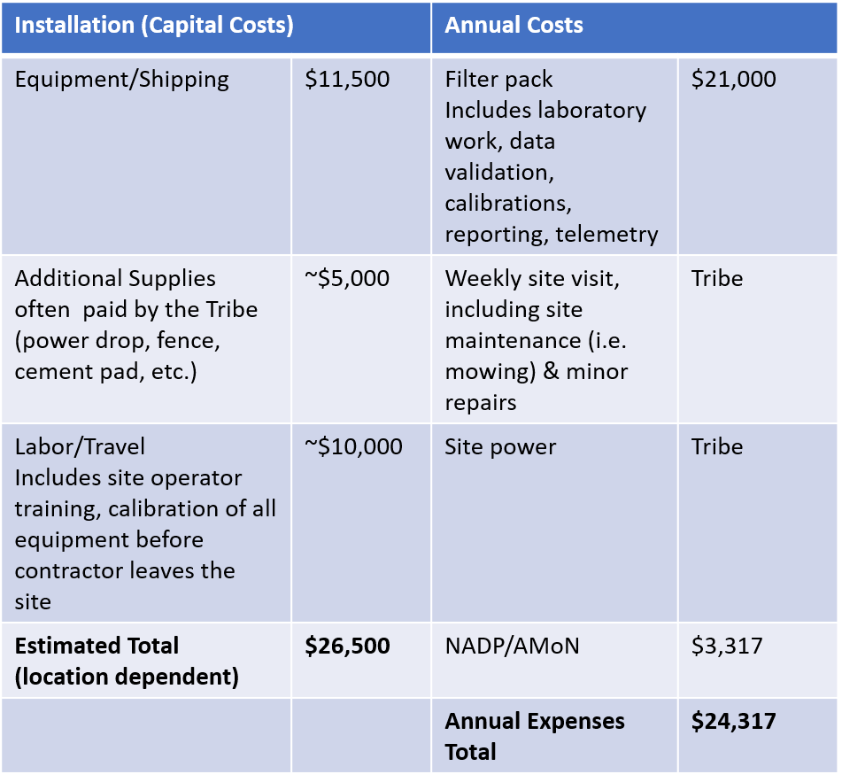
Table 5 Estimated costs for including ozone measurements at the small-footprint CASTNET site. These are in addition to the costs shown in Table 2 above. The annual operating costs for the ozone monitor are shown on the right.
