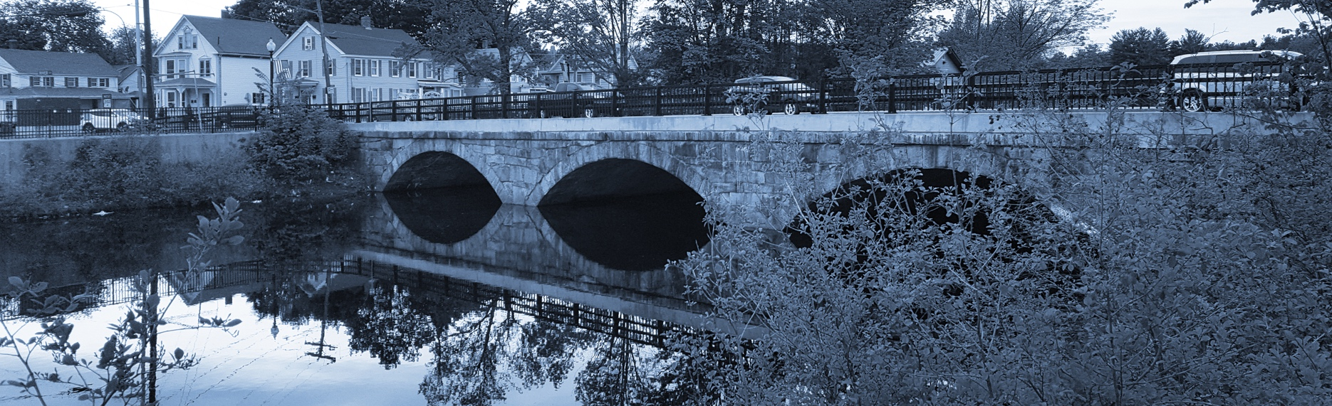
Long-Term Stormwater Planning
Part of the Suite of Integrated Planning Resources

Describe Relevant Requirements and Drivers
Make Connections with Stakeholders




Worksheet 1: Identify Stakeholders and Ways to Engage
This worksheet is part of a series of 10 worksheets referenced in Long-Term Stormwater Planning: A Voluntary Guide for Communities. The worksheets present questions and prompts for each step in the planning process to help communities document their process and decisions. They are intended to be an easy-to-use tool that a community can reference; populate; expand upon; and even incorporate directly into an integrated plan, long-term stormwater plan, or other community plan.
This worksheet supports one of the first parts of the planning process, which is assessing where you are now. Answering the groundwork questions in the worksheet below will help you identify stakeholders in your long-term stormwater planning process. You may also use the second table in this worksheet to identify potential collaborators that you may want to contact to participate in your process as you formulate and implement your long-term plan. Remember that the long-term stormwater planning process should be tailored to your community. Feel free to add questions and/or modify this worksheet to best suit your needs.
This worksheet helps a community make connections with stakeholders as part of Element 3 of the Integrated Planning Framework.

Groundwork Questions to Identify Stakeholders
Groundwork Questions | Response
Who should be involved in the long-term stormwater planning process?
Examples include community groups, municipal departments, individuals, residents, commercial and industrial entities, watershed groups, housing groups, academic institutions, economic development organizations, and regulatory authorities that may be affected by stormwater management decisions or have priorities and resources that align with the effort. These groups or individuals may be specifically interested in stormwater or interested in other related community efforts. See the table below for a list of potential collaborators. You could consider using information from previous surveys, discussions, and focus groups to inform stakeholder selection.
These are your stakeholders. See pages 4-6 of this worksheet for a list of potential collaborators.
What under-resourced and disproportionately impacted community members could you engage?
Identify those who may have not been engaged in previous efforts and consider what may have prevented their involvement and how to address any issues. Examples of barriers include the language of outreach materials, method of outreach, time and location of public meetings, and stated emphasis of meetings.
Who is/are the champion(s) of this effort?
A staff champion works as a team leader and overall advocate for the team. A manager champion supports the team, provides input, and advocates on behalf of the team.
What is each stakeholder’s stormwater-related priorities?
Encourage stakeholders to identify existing priorities, including those not obviously connected to stormwater. Connections and opportunities for multi-benefit projects may become clear in subsequent steps.
Are there clear areas of intersection or commonality across stakeholder priorities?
Grouping overlapping interests can help inform your next steps and guide how strategies are structured.
When and how will each stakeholder be involved in this effort?
Identify how you will engage with these partners throughout the process. Identify the ways in which your stakeholders want to stay informed, provide input, and be involved. Seek direct input from groups and individuals on best strategies for keeping them engaged in the process. Think about how these partners would use or benefit from the outcomes of long-term stormwater planning.
How do you plan to obtain input and feedback from each stakeholder?
Seek out meaningful involvement of stakeholders who are impacted by stormwater challenges and/or can benefit from stormwater improvements. Facilitating authentic community engagement may require holding meetings at various times, sharing information in multiple languages via numerous delivery mechanisms, and making several options available for stakeholders to provide input.
How will you set and prioritize goals, implementation strategies, and schedules based on stakeholder feedback?
Decide how you will ensure that feedback is used throughout the process to help set, prioritize, and implement goals, strategies, and schedules. Consider using feedback to set goals rather than modifying goals based on feedback.

Potential Collaborator Contact List
Collaborators can provide valuable input throughout the long-term stormwater planning process and likely need to be engaged with while you assess where you are, when you analyze opportunities, and when you move toward implementation.
Potential Collaborator Category | How They Can Help Throughout the Process | Contact(s)
For example, local colleges | Environmental and public policy departments may have conducted similar studies or have expertise that can help you conduct some of the assessment techniques for engaging the community.  Engage local colleges early in the process to discuss best practices for public engagement. | Dr. Jane Doe, Assistant Professor of Public Policy
Community-based organizations
Environmental/watershed organizations
Civic groups
Religious organizations
Senior centers
Social service organizations
Community advocacy organizations
Housing groups
Government
Local government departments like transportation departments, parks and recreation, public works, etc.
Local government decision-makers
State government
Federal government
Local associations
Homeowners association, renters association, housing advocacy organization
Neighborhood councils
Parent-teacher associations
Gardening clubs
Biking groups
Recreation and tourism interests
Historic and cultural organizations
Commercial and industrial entities
Developers
Academic institutions
Note: Information in this table is from Community Culture and the Environment: A Guide to Understanding a Sense of Place, 2002, U.S. EPA (EPA 842-B-01-003), Office of Water, Washington, D.C.

