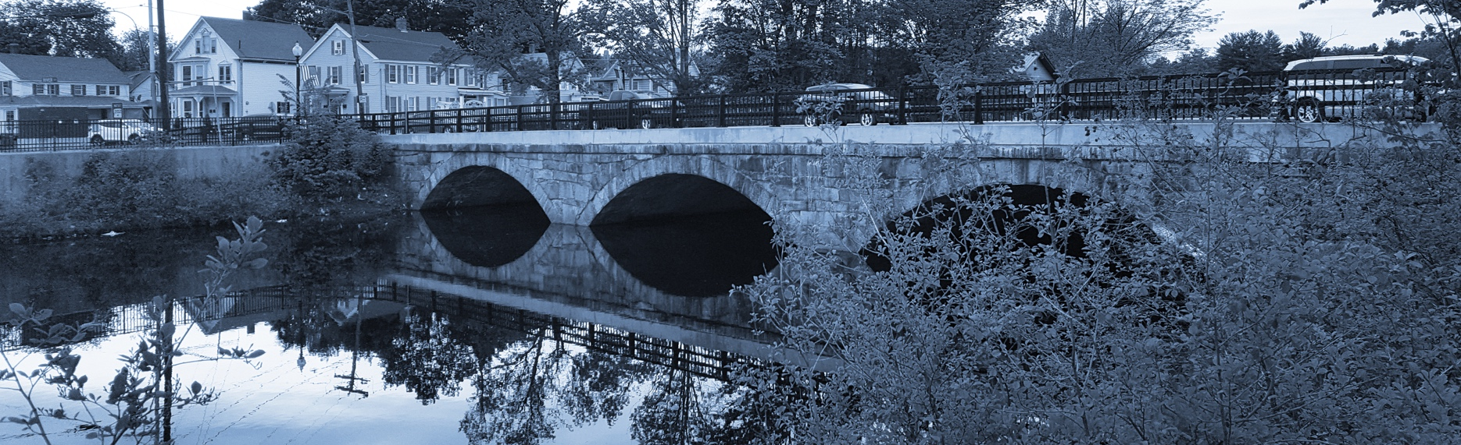
Long-Term Stormwater Planning
Part of the Suite of Integrated Planning Resources
Measure Performance
Adapt for Success




Worksheet 10: Strategy Status Evaluation
This worksheet is part of a series of 10 worksheets referenced in Long-Term Stormwater Planning: A Voluntary Guide for Communities. The worksheets present questions and prompts for each step in the planning process to help communities document their process and decisions. They are intended to be an easy-to-use tool that a community can reference; populate; expand upon; and even incorporate directly into an integrated plan, long-term stormwater plan, or other community plan.
This worksheet is part of the latter portion in the planning process: move toward implementation. Fill in the table with each strategy and associated objective(s) from Worksheet 7. This worksheet is intended to be used periodically to capture the status of strategy implementation. It may be used multiple times throughout the goal implementation process. Remember that the long-term stormwater planning process should be tailored to your community. Feel free to add questions and/or modify this worksheet to best suit your needs.
This worksheet helps a community measure performance as part of Element 5 and adapt for success as a part of Element 6 of the Integrated Planning Framework.

Example Strategy Status Evaluation Table
Example Strategy Name | Example Objective | Example Performance Metric(s) | Example Strategy Evaluation Notes
Develop an asset inventory | By 2030, 100 percent of the stormwater management assets in the city will be tracked in a comprehensive database. | Percentage of stormwater and green infrastructure assets that the city has mapped and inventoried. | 2021: 1,000 out of 1,500 (67 percent) assets are mapped by 2027.
Update regulatory codes and ordinances to require green infrastructure | By 2030, 60 percent of projects on privately owned land include green infrastructure in their designs to comply with post-construction stormwater management requirements. | Percent of development/redevelopment projects with designs that include green infrastructure. | 2022: 40 percent of projects include green infrastructure.  2023: 45 percent of projects include green infrastructure.
Update Infrastructure Design Standards | By 2027, decrease project review time by the city by 10 percent. | Amount of time it takes to review projects. | 2022: 6 weeks  2023: 5 weeks
Establish an offsite stormwater program | Annually decrease the number of stormwater management waivers issued by the city for redevelopment projects. | Number of waivers issued by the city to applicants who can’t meet stormwater management redevelopment criteria.  Number of sites that participate in the offsite stormwater program.  Pollutant load estimates from sites participating in the offsite stormwater program. | 2022: 32 waivers  2023: 30 waivers
Implement green infrastructure on public parcels | Annually increase the amount of impervious area treated by green infrastructure on publicly owned land. | Acres of impervious area treated by green infrastructure on publicly owned land. | 2022: 4 acres  2023: 6 acres

Strategy Status Evaluation Table Template

Strategy Name | Objective | Performance Metric(s) | Strategy Evaluation Notes

