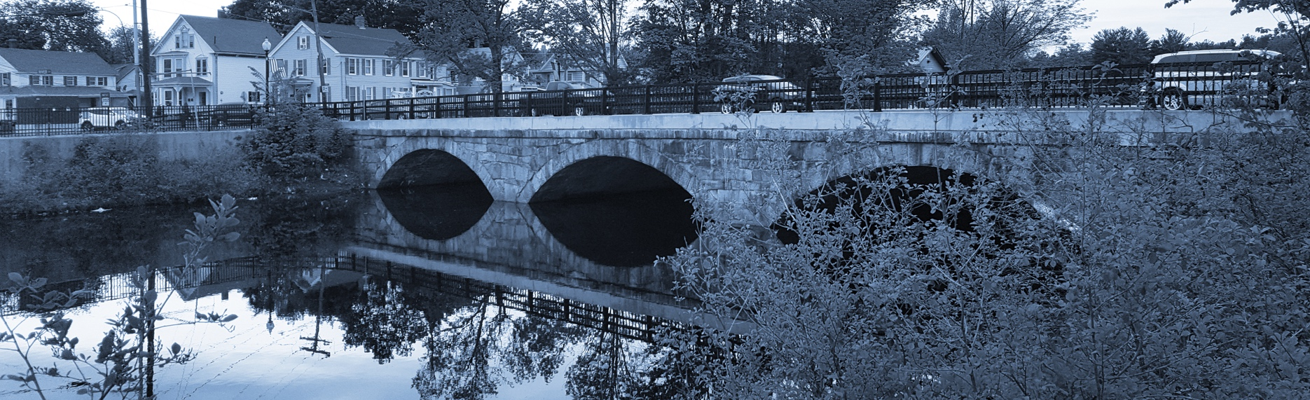
Long-Term Stormwater Planning
Part of the Suite of Integrated Planning Resources
Describe Relevant Requirements and Drivers



Worksheet 2: Identify Drivers and Issues
This worksheet is part of a series of 10 worksheets referenced in Long-Term Stormwater Planning: A Voluntary Guide for Communities. The worksheets present questions and prompts for each step in the planning process to help communities document their process and decisions. They are intended to be an easy-to-use tool that a community can reference; populate; expand upon; and even incorporate directly into an integrated plan, long-term stormwater plan, or other community plan.
This worksheet supports one of the first parts of the planning process, which is assessing where you are now. Answering the groundwork questions in the worksheet below will help you document drivers and issues that impact your long-term stormwater planning process. Remember that the long-term stormwater planning process should be tailored to your community. Feel free to add questions and/or modify this worksheet to best suit your needs.
This worksheet helps a community identify requirements and drivers as part of Element 1 of the Integrated Planning Framework.

Groundwork Questions to Identify Drivers and Issues
Groundwork Questions | Response
What existing community plans and documents do you have to inform your goals and opportunities for improving stormwater management?
Examples could include master plans, comprehensive plans, and capital improvement plans that cover a variety of topics including transportation, recreation, stormwater, land use, waterfront, downtown areas, and economic development.
Has stormwater negatively impacted specific neighborhoods or locations?
This includes localized flooding, basement backups, and deferred stormwater infrastructure maintenance.
What environmental justice and supplemental indexes like traffic proximity, hazardous waste proximity, and superfund proximity, should be considered when planning stormwater infrastructure?
Examples of environmental and demographic indices can be found on EPA’s EJScreen website.
What challenges does your community currently face?
This may include stormwater and non-stormwater challenges. Challenges may be related to climate change, economic development, resilience, funding, infrastructure maintenance, pollution, recreational areas, overburdened or underserved populations, etc. Note if there are current challenges in meeting any regulatory requirements.
What other challenges does your community expect to face in the future?
For example, those related to growth, infrastructure deficiencies, anticipated increased/decreased precipitation.
How does stormwater intersect with your current and anticipated challenges?
Think about ways your stormwater volumes and associated pollutant loads may increase/decrease under these expected challenges.
What Clean Water Act obligations does your community have?
This may be current or anticipated and include things such as municipal separate storm sewer system (MS4) permit requirements, total maximum daily loads, wasteload allocations, etc.
What other water quality or human health drivers does your community have that may relate to stormwater management?
For example, local waterbodies not meeting designated uses could put swimmers, boaters, and others using the water at risk of illness, impact fishing, and create algal blooms. Stormwater management and the use of green infrastructure could help reduce these impacts while also providing other community benefits.
What geographic areas, activities, and environmentally sensitive areas do you need or want to protect?
Examples could include specific waterbodies, forests, and wetlands.
What geographic areas and activities does your community want to protect or improve?
List areas important to the community, which may include recreational spaces, areas with cultural significance, or areas with overburdened or underserved populations. You may find this information is linked to zoning decisions.

